**DEVELOPMENT OF A PORTABLE INCUBATOR FOR THE DETECTION OF COLIFORM IN WATER USING IOT**

**BY**

**OLONISAKIN DAVID AKOLADE**

**(18CK024244)**

**A PROJECT REPORT SUBMITTED TO THE DEPARTMENT OF ELECTRICAL & INFORMATION ENGINEERING, IN PARTIAL FULFILLMENT OF THE REQUIREMENTS FOR THE AWARD OF THE BACHELOR OF ENGINEERING DEGREE IN ELECTRICAL AND ELECTRONICS ENGINEERING.**

**SUPERVISOR:**

**DR. OSEMWEGIE OMORUYI**

**JUNE 2023**

## 

## DECLARATION

I, OLONISAKIN DAVID AKOLADE (18CK024244), hereby declare that I carried out the work reported in this project in the Department of Electrical and Information Engineering, Covenant University, under the supervision of Dr. Osemwegie Omoruyi. I also solemnly declare that to the best of my knowledge; no part of this report has been submitted here or elsewhere in a previous application for the award of a degree. All sources of knowledge used have been duly acknowledged.

…………………………………………….

OLONISAKIN DAVID AKOLADE

18CK024244

## CERTIFICATION

This is to certify that the project titled “**DEVELOPMENT OF A PORTABLE INCUBATOR FOR THE DETECTION OF COLIFORM IN WATER USING IOT**” by Olonisakin David Akolade, meets the requirements and regulations governing the award of the Bachelor of Engineering in Electrical and Electronics Engineering degree of Covenant University and is approved for its contribution to knowledge and literary presentation.

**Supervisor 1:** Sign: _________________ ____________________

Name: Dr. Osemwegie Omoruyi Date:

**Internal Examiner:** Sign: _________________ ____________________

Name:Date:

**Head of Department:** Sign: _________________ ____________________

Name: Dr. Isaac SamuelDate:

## DEDICATION

This research project is dedicated to my parents, Dr. Rotimi Olonisakin and Mrs. Bolatito Olonisakin who were very understanding and supportive throughout the time taken to complete this project, providing the resources necessary to make this project possible. I also dedicate this project to the countless communities in Nigeria who lack access to clean water.

## ACKNOWLEDGEMENTS

First and foremost, I would like to begin by expressing my deepest gratitude to God for His divine guidance, wisdom, and grace throughout this project. I am forever grateful for His constant presence and blessings in my life.

I would also like to extend my sincere appreciation to my parents for their unwavering love, support, and encouragement. Their sacrifices, guidance, and prayers have been a source of strength and motivation throughout this journey. I am truly blessed to have them as my role models.

I would like to take this opportunity to express my deepest appreciation and gratitude to my exceptional project partner, Oguibe Favour Ozioma. Together, with a harmonious blend of teamwork, unwavering dedication, and the power of prayers, we successfully transformed our shared idea into a remarkable reality.

I would like to express my heartfelt thanks to my project supervisor, Dr. Osemwegie Omoruyi for His invaluable guidance, expertise, and support. His insightful feedback, constructive criticism, and dedication have been instrumental in shaping the direction and success of this project.

Furthermore, I want to thank the Head of Department, Dr. Isaac Samuel, and all my lecturers for impacting me with knowledge and passing me through various tasks that have, in one way or the other, prepared me for the gallant execution of this project.

Finally, I would also like to acknowledge the support and encouragement of my lovely sisters, Favour and Delight Olonisakin, who have been there for me through thick and thin. Their kind words, motivational messages, and belief in my abilities have helped me to stay focused and motivated.

## ABSTRACT

Having access to clean and safe drinking water is considered a crucial human right, yet millions of individuals continue to live without it. The consumption of water that has been contaminated can increase the risk of experiencing outbreaks of different diseases that are transmitted through water, which are a leading cause of death worldwide. This project aims to develop a portable and low-cost incubator for detecting coliform bacteria in water, which is achieved by using a light-dependent resistor (LDR) and a heating element controlled by an IOT equipped microcontroller (ESP32). The incubator creates a controlled environment for water samples to incubate and for the LDR sensor to detect changes in turbidity, indicating the presence of coliform bacteria. Additionally, a Digital Humidity and Temperature (DHT11) sensor and a heating element helps maintain a temperature range of 35-37°C, the ideal temperature for optimal coliform bacteria growth. The incubator also features a Liquid Crystal Display (LCD) displaying resistance and temperature readings. After the data is collected, it is transferred to the microcontroller and subsequently transmitted to the Blynk application for continuous monitoring and analysis in real-time. The portability and affordability of this incubator makes it appropriate for use in remote areas where access to laboratory equipment is limited. This study carries significant implications for the advancement of low-cost and portable water quality monitoring systems, potentially leading to improvements in public health.

Keywords: ***portable incubator, coliform bacteria , water monitoring, light-dependent resistor*.**

## TABLE OF CONTENT

**DECLARATION ii**

**CERTIFICATION iii**

**DEDICATION iv**

**ACKNOWLEDGEMENTS v**

**ABSTRACT vi**

**TABLE OF CONTENT vii**

**LIST OF TABLES x**

**LIST OF FIGURES xi**

**LIST OF ABBREVIATIONS xiii**

CHAPTER ONE 1

**INTRODUCTION 1**

1.1 Background of Study 1

1.2 Significance of Study 2

1.3 Problem Statement 2

1.4 Aim and Objectives 2

1.5 Methodology 2

1.5.1 Waterfall Model of Methodology 3

1.5.2 Description of the Waterfall model 3

1.6 Scope of Study 4

1.7 Limitations of the Study 5

1.8 Project Organization 5

CHAPTER TWO 7

**LITERATURE REVIEW 7**

2.1 Introduction 7

2.2 Coliform Bacteria: A Quick Overview 7

2.3 Significant Factors that promote Coliform Bacteria infestation in water 9

2.3.1 Septic Tank Systems. 10

2.4 The significance of finding Coliform bacteria in water 15

2.5 Traditional methods of detecting Coliform in water 16

2.5.1 Membrane filter method 17

2.5.2 Multiple-tube fermentation technique 17

2.5.3 Molecular methods 18

2.5.4 Enzymatic method/defined substrate method. 20

2.6 Internet of Things (IOT): A Quick Overview 21

2.6.1 Structure of the Internet of Things (IOT) 22

2.6.2 IOT's relevance for detecting bacteria in water and its utility in detecting coliform 24

2.7 Review of related works 25

2.8 Summary 29

CHAPTER THREE 30

**SYSTEM ANALYSIS AND DESIGN 30**

3.1 Introduction 30

3.2 Components 30

3.2.1 ESP 32 30

3.2.2 Light Dependent Resistor (LDR) 31

3.2.3 Relay 31

3.2.4. DC-DC Buck Converter 32

3.2.5 PTC Electrical Heating Element 33

3.2.6 LED Bulb 33

3.2.7 DHT11 Temperature and Humidity Sensor 34

3.2.8 Liquid Crystal Display (LCD) 34

3.2.9 I2C Serial Interface Adapter Module 35

3.2.10 Incubator 35

3.2.11 Beaker 36

3.2.12 Water Detect Coliform Powder 36

3.2.13 Power Supply Adapter 37

3.2.14 10k resistors 38

3.2.15. Polyethylene foam 38

3.4 Description of Software Requirements 39

3.4.1 Arduino Integrated Development Environment (IDE) 39

3.4.2 Blynk 40

3.3 Design specification 42

3.3.1 Systems Block Diagram 42

3.3.2 Circuit Diagram 42

3.3.3 Systems Algorithm 43

3.3.4 Systems Flowchart 45

3.3.5 Electrical Calculations 45

3.5 Conclusion 49

CHAPTER FOUR 50

**RESULTS AND DISCUSSIONS 50**

4.1 Introduction 50

4.2 Hardware Implementation 51

4.2.1 DHT 11 sensor and PTC heating element testing 53

4.2.2 Relay and PTC heating element connection 55

4.3 LDR calibration and testing 58

4.3.1 Calibration and Mapping of LDRs 59

4.3.2 Final results 63

4.4 Bill Of Engineering Material and Evaluation (B.E.M.E) 67

4.5 Summary 67

CHAPTER FIVE 68

**CONCLUSIONS AND RECOMMENDATIONS 68**

5.1 Conclusion 68

5.2 Achievements 69

5.3 Challenges encountered 69

5.4 Recommendations 70

**REFERENCES 72**

## LIST OF TABLES

Table 3.1: Component Voltage and Current Values 48

Table 4.1: Bill Of Engineering Material and Evaluation (B.E.M.E) 67

## LIST OF FIGURES

Figure 1.1: Waterfall model 3

Figure 2.1: Different Groups of Coliform Bacteria [7] 9

Figure 2.2: IoT Analytics Flow [60] 23

Figure 3.1: Expressif Systems Processor (ESP) 32 31

Figure 3.2: Light Dependent Resistor (LDR) 31

Figure 3.3: Relay 32

Figure 3.4: DC-DC Buck Converter 32

Figure 3.5: Heating Source 33

Figure 3.6: LED Bulb 33

Figure 3.7: DHT 11 34

Figure 3.8: Liquid Crystal Display 34

Figure 3.9: I2C Serial Interface Adapter Module 35

Figure 3.10: Incubator 36

Figure 3.11: Beaker 36

Figure 3.12: Water Detect Coliform Powder 37

Figure 3.13: Power Supply Adapter 37

Figure 3.14: 10k resistors 38

Figure 3.15: Polyethylene foam 38

Figure 3.16: Arduino Integrated Development Environment (IDE) 39

Figure 3.17: Arduino Integrated Development Environment (IDE) Code Snippet 40

Figure 3.18: Blynk Application 41

Figure 3.19: Systems Block Diagram 42

Figure 3.20: Circuit Diagram 42

Figure 3.21: Systems Flowchart 45

Figure 4.1: Inside of incubator with base padded with polyethylene foam 51

Figure 4.2: Beaker stand 52

Figure 4.3: LDR legs attached to base of beaker 52

Figure 4.4: Internal image of incubator showing wiring to the outside 53

Figure 4.5: DHT pin configuration 54

Figure 4.6: DHT 11 to ESP32 wiring diagram 54

Figure 4.7: Single Channel relay pin-out Diagram 55

Figure 4.8: Image of code showing heating element conditions 56

Figure 4.9: Relay to heater connection diagram 57

Figure 4.10: Image showing final soldering and wiring 57

Figure 4.11: Voltage divider circuit for LDR 58

Figure 4.12: Serial monitor readings of LDR resistance readings while LED off 59

Figure 4.13: Code showing mapped LDR resistance values 60

Figure 4.14: Water sample containing coliform bacteria mixed with water detect coliform powder 61

Figure 4.15 : Water sample after 16 hours of incubation 62

Figure 4.16: Color of water sample uninfected with coliform bacteria after 16 hours of incubation 62

Figure 4.17: LDR readings when beaker with contaminated water was placed on each LDR 63

Figure 4.18: Showing results when sample beaker is on LDR 1 64

Figure 4.19: Showing results when sample beaker is on LDR 2 65

Figure 4.20: Showing results when sample beaker is on LDR 3 66

## LIST OF ABBREVIATIONS

AC: Alternating Current

DC: Direct Current

DHT: Digital Humidity and Temperature

EEPROM: Electrically Erasable Programmable Read-Only Memory

E. coli: Escherichia coli

ESP: Expressif Systems Processor

GPIO: General Purpose Input Output

I2C: Inter Integrated Circuit

IDE: Integrated Development Environment

IOT: Internet of Things

LCD: Liquid Crystal Display

LDR: Light Dependent Resistor

LED: Light Emitting Diode

OS: Operating System

PTC: Positive Temperature Coefficient

# CHAPTER ONE

## INTRODUCTION

### 1.1 Background of Study

The research was inspired by the need for precise and trustworthy techniques for identifying waterborne infections, especially coliform bacteria, in places with few laboratory facilities. Coliform bacteria are used as a quality gauge for water and are a sign that potentially dangerous diseases may be present. Ensuring the availability of safe drinking water stands as a key priority in public health efforts because it is intimately related to human health. Consuming water that contains hazardous chemicals or pathogenic organisms has a major influence on one's health[1].

The lack of low-cost, simple-to-use, and accurate techniques for remote water monitoring and coliform detection is the key issue driving this research. Due to difficulties with transportation, sample storage, and inadequate laboratory facilities, traditional laboratory-based approaches are frequently not practical in remote places. Thus, the creation of a mobile incubator for coliform detection could be the answer to this issue.

The project is aimed towards developing a portable incubator that can quickly and accurately detect coliform bacteria in water using an approach that is both affordable and simple to use. One approach to detect these organisms involves filtering a 100 mL water sample through a membrane. Subsequently, the filtered membrane is incubated on specialized media at temperatures ranging from 35 to 37 °C for E. coli or 44 to 45 °C for TTC[2]. The issue of restricted access to laboratory facilities for water monitoring and coliform detection can be resolved by the portable incubator, especially in distant locations. The study is important because it may increase access to clean water, especially in locations where waterborne diseases are common. The mobile incubator might also be used for environmental research and monitoring, which would improve water management and public health.

## 

### 1.2 Significance of Study

The development of a portable incubator for remote water monitoring and detection of coliform is an important initiative that can improve access to safe water, particularly in remote areas. Traditional laboratory-based methods for coliform detection are often not feasible in such areas due to transportation, sample storage, and limited laboratory facilities.

This project aims to address the problem of limited access to laboratory facilities by providing a low-cost, easy-to-use, and reliable method for remote water monitoring and coliform detection. The portable incubator is designed to use a LDR and a light bulb, where a resistance drop or increase is detected depending on the coliform growth. Afterward, this data is transmitted to the ESP32 for additional analysis. Additionally, a DHT 11 sensor is in place to regulate the temperature of the incubator at 35-37 degrees Celsius via the heater. The significance of this study is highlighted below;

1. Improve access to safe water, particularly in remote areas.
2. Enhance public health efforts in identifying and preventing waterborne diseases.
3. Contribute to water management and environmental monitoring research.
4. Increase efficiency in water monitoring by eliminating transportation of water samples for analysis in a laboratory
5. Enable citizen science initiatives for community-led efforts towards sustainable water management.

### 1.3 Problem Statement

The current methods for detecting coliform bacteria in water samples require laboratory analysis, which can be time-consuming and resource-intensive. This can limit the ability to effectively monitor water quality, particularly in remote areas. Therefore, there is a need for a portable incubator that can detect coliform bacteria remotely, and enable more efficient and timely water monitoring activities.

### 1.4 Aim and Objectives

**Aim**: To develop a portable incubator for remote water monitoring and detection of coliform.

**Objectives**

The project has the following objectives:

1. To develop and construct a portable incubator capable of maintaining a specific temperature range of 35-37°C using a ESP32-powered relay to control the heating element and sensor readings.
2. To detect coliform bacteria growth using an LDR sensor and a bulb by monitoring the changes in resistance.
3. To develop a real-time monitoring and data visualization of coliform levels.
4. To validate the accuracy and effectiveness of the portable incubator in detecting coliform bacteria.

### 1.5 Methodology

The proposed research falls under the field of environmental science and seeks to examine the quality of water samples that are already contaminated with coliform bacteria. The project will utilize the Waterfall model of methodology, an iterative process for creating a system or solving a problem that structures the entire job into segments to ensure precision.

#### 1.5.1 Waterfall Model of Methodology

This project has been successfully accomplished by implementing the following strategy:

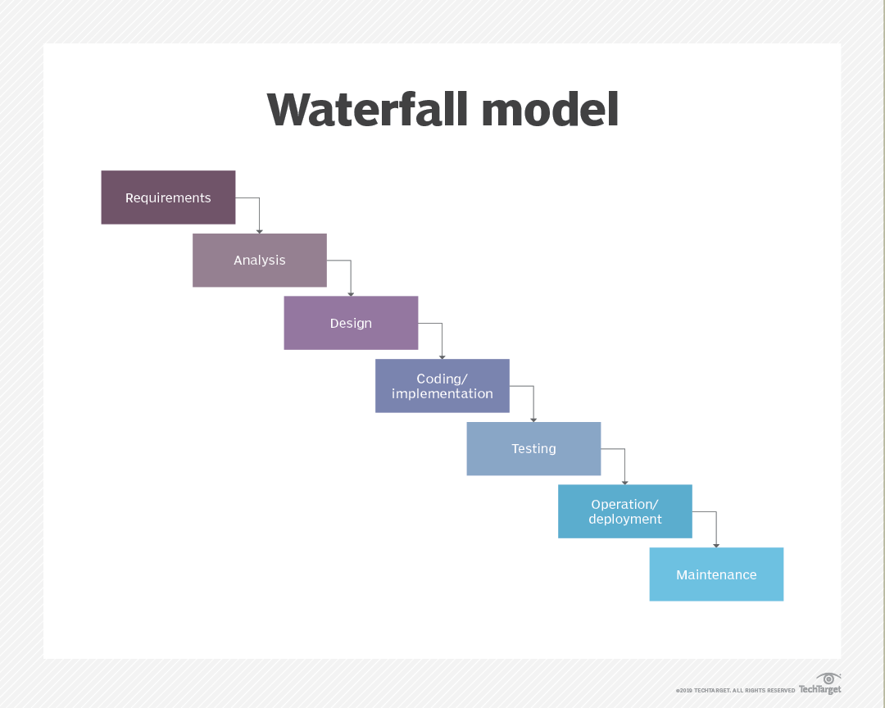

Figure 1.1: Waterfall model

#### 1.5.2 Description of the Waterfall model

The work has been grouped into seven sections;

1. Requirements Gathering Phase: In this phase, the aim and objectives of the project will be defined, and the specific requirements for the research will be gathered.
2. Analysis Phase: In this phase, the water samples containing coliform will be analyzed, and the most suitable water samples for the experiment will be identified and selected based on specific criteria.
3. Design Phase: In this phase, the portable incubator will be designed, and the DHT11 sensor and LDR will be integrated into the system.
4. Implementation Phase: In this phase, the incubator will be set up, and the selected water samples will be placed in it. The temperature and light exposure within the incubator will be monitored using the DHT11 sensor and LDR, respectively.
5. Testing Phase: In this phase, any changes in the resistance levels of the LDR due to bacterial growth in the water samples will be recorded.
6. Deployment Phase: The data acquired during the testing phase will undergo statistical analysis to identify and quantify the existence of coliform bacteria in the water samples. Statistical methods will be employed to assess the presence and concentration of coliform bacteria based on the collected data.
7. Maintenance Phase: During this phase, any required modifications to the experiment will be implemented in response to the discoveries and outcomes of the investigation. Finally, conclusions and suggestions will be drawn based on the results obtained.

### 1.6 Scope of Study

The primary focus of this research is to conceive and create an economical and easily transportable incubator tailored for remote monitoring of water quality and identification of coliform bacteria. The incubator will utilize a light-dependent resistor (LDR) to detect changes in turbidity, and a DHT11 sensor to maintain a consistent temperature of 35-37°C inside the incubator. The incubator's operation will rely on a 230 AC – 5V DC power supply and monitored using ESP32 module. The study will involve designing and constructing the incubator, testing its sensitivity and specificity for detecting turbidity increases, and evaluating its performance in a real-world setting. The study aims to provide a cost-effective and efficient solution for monitoring water quality in remote areas where access to laboratory equipment is limited.

### 1.7 Limitations of the Study

Limitations associated with this project include:

1. The precision of coliform detection might be influenced by various factors, including the quality of the water sample and the calibration of the LDR sensor.
2. The use of an ESP32 microcontroller for data transmission may have limited range and reliability in remote areas with poor internet connectivity.
3. The incubator may require frequent calibration and maintenance to ensure consistent temperature and humidity levels for accurate readings.
4. The heating source required to increase the temperature in the incubator uses up a significant amount of power, which makes it impractical to use a battery as a power source.
5. The size and portability of the incubator may limit the amount of water samples that can be tested at once, potentially affecting the scalability of the system.

### 1.8 Project Organization

The report is structured into five chapters, each contributing to a comprehensive understanding of the project. Chapter One serves as a broad introduction, providing a general perspective on the research, contextual background, specific goals and objectives, targeted issues, and a concise outline of the chosen methodology. In Chapter Two, a thorough literature review is presented, delving into relevant studies to establish a theoretical framework and provide additional insights crucial for a comprehensive grasp of the project. Chapter Three focuses on the project's methodology, discussing the necessary components, specifications, design considerations, and innovations, including system block diagram representation and hardware design. Moving on to Chapter Four, the implementation and testing of the project are covered, showcasing the practical system design and featuring in-progress photos. This chapter also entails a comprehensive examination and analysis of the project's findings and outcomes. Finally, Chapter Five serves as the concluding chapter, summarizing the study's conclusive remarks, outcomes, and displaying the project's achievements.

# CHAPTER TWO

## LITERATURE REVIEW

### 2.1 Introduction

Many researchers have investigated the prevalence of coliform bacteria in various sources of water. Coliform bacteria existence in drinking water is a huge public health concern. Although total coliform bacteria are widespread and typically not harmful, the presence of fecal coliforms and E. coli may pose a potential danger to human health. Coliform bacteria, including total coliforms, fecal coliforms, and E. coli, are frequently employed as indicators of water quality. [3] . This chapter provides a comprehensive overview of Coliform bacteria, including the major factors that contribute to their presence in water, the potential health effects of exposure to these bacteria, traditional methods for detecting them in water, relevance of IoT technology in the detection of Coliform bacteria in water and review similar works in the literature.

### 2.2 Coliform Bacteria: A Quick Overview

Coliform bacteria are rod-shaped, non-spore-forming, Gram-negative, oxidase-negative, facultatively anaerobic organisms that have a cell wall appearing pink or red when stained and can survive in both oxygenated and non-oxygenated environments [4]. Coliforms are a class of bacteria that are present in soil, plants, and the digestive tracts of all animals, including humans. While most coliforms are harmless, the presence of certain coliforms, like E. coli, in drinking water might signal that the water may be polluted with feces, which increases the risk of illness. The presence of additional pathogens is possible if E. coli is discovered in the water, since E. coli itself can be a pathogen. The intestine of warm-blooded mammals is where it typically began [5]. In the past, the presence of the intestinal bacteria known as coliforms has been cited as a sign that a location has been contaminated by sewage from people. Additionally, the feces of affected people contain harmful germs including Shigella and Salmonella[6].

Coliform bacteria are classified into three types that indicate the safety of water and differ in the level of risk. The term "total coliform" encompasses a wide range of bacteria, including those present in fecal matter, which is a subset of all coliforms. One variety of fecal coliform bacteria is E. coli. When testing drinking water samples, laboratories check for the presence of total coliform, and if it is detected, the sample is further examined see whether it contains E. coli[3]. Total coliform bacteria presence is commonly observed in nature and does not pose a significant threat. Drinking water contamination is most likely environmental when only total coliform bacteria are found in it[7].

1.Total Coliform Bacteria:The common bacteria in the ecosystem known as total coliforms is usually found in dirt or plants, and is widely regarded safe. If a laboratory only observes total coliform bacteria in drinking water research, then it is likely that the bacteria came from the environment and fecal pollution is rare. However, there is a chance that harmful germs could get inside the system if it is prone to external pollution. As a result, It is crucial to identify and address the primary cause of the contamination.

2.Fecal Coliform Bacteria:In the intestines and feces of both humans and animals, fecal coliform bacteria, a subtype of total coliform bacteria, are prevalent. The identification of fecal coliforms in a water sample is typically indicative of recent fecal contamination, and this poses a higher risk of potential pathogen presence compared to situations where just total coliform bacteria are identified[7].Top of Form

3. Escherichia coli: The bulk of E. coli types usually pose little worry and typically live in the intestines of warm-blooded creatures like humans. E. coli is a subset of fecal coliform germs. However, some kinds of E. coli can make people ill. When E. coli bacteria are found in a portable water sample, it usually means that there has been recent fecal pollution, which boosts the chance that disease-causing germs are present [7]. The identification of E. coli in water samples typically indicates contamination with feces, along with the potential existence of human-originating harmful organisms [7]. Since E. coli can also be a pathogen, there is a possibility that other pathogens will also be present if E. coli is discovered in the water[5]. Escherichia coli bacteria were typically found in sewage discharges from human, animal, and plant sources, in that order. Septic system failure, municipal landfills, and wastewater sludge application to the land are all examples of human sources. Numerous animal sources, including domestic pets, wild animals, cattle, the spreading of manure on land, pastures, and feedlots, can release fecal coliform bacteria into the environment[8].

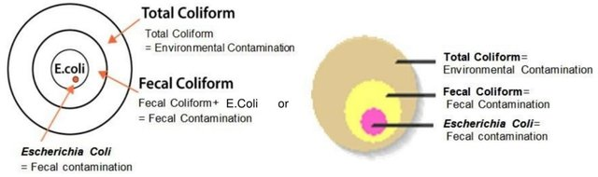

Figure 2.1: Different Groups of Coliform Bacteria [7]

### 2.3 Significant Factors that promote Coliform Bacteria infestation in water

Water sources containing coliform bacteria pose a significant risk to the public's health and are frequently contaminated by feces due to improper sanitation practices or agricultural activities. It has been claimed that septic tank systems and farm waste are the main contributors to coliform bacteria in drinking water. Septic tank overflow and other related factors contaminating drinking water sources with human feces particularly raise the risk of Coliform contamination. The risk of contracting a waterborne disease can also be increased by the use of pesticides and fertilizers in agriculture, which can reduce the spread of coliform bacteria to water sources. To protect public health and stop the spread of infectious diseases, coliform bacteria must be found and monitored in drinking water.

#### 2.3.1 Septic Tank Systems.

Water contamination is one of the biggest problems in the world today. Septic tank effluent intrusion is one of the main causes of groundwater contamination. the principal origin of harmful viruses and bacteria in the subterranean environment may be septic tank effluent[9]. Contamination of aquifers has become a common problem as a result of excessive groundwater pumping and uncontrolled human wastewater dumping into the groundwater. Groundwater quality can be impacted by residential, business, industrial, and agricultural activities. Groundwater is particularly sensitive in regions with large population densities and extensive human use of the land[10]. Waste is temporarily stored in a septic tank while being pre-treated at that time. There have been reports of septic tanks failing and leaking a lot, harming the ecosystem[11]. Researchers from several fields have done studies to show the detrimental effects of situating septic tank systems close to drinking water sources. An examination investigating the impacts of septic tank distances from wells and groundwater contamination in the Agbowo suburb of Ibadan, Nigeria, was done[12]. Septic tanks have been proven to malfunction and leak a lot, harming the environment [11]. Therefore, septic tanks are the primary source of waste that is directly released into groundwater. Monitoring of water is therefore crucial to protect both the environment and human health[13]. Forty (40) ground water samples were replicated, and they were taken from groundwater sources at different distances for bacteriological analysis, and it was found that they were all infected with different types of bacteria as well as coliform[12]. The number of feces and total coliforms decreased with increasing distance from septic tanks, and this effect was more pronounced for water supply distance from pollution sources. Because the problem of septic tank contamination of ground water is a national concern rather than a local one in the study region, Standards should be created for the separation of wells from septic tanks and the pretreatment of well water[12]. Consuming groundwater that has been faecally contaminated and not properly treated has been related to disease[14].

Underground water, or the water found below the earth's surface in soil pores and rock formation fractures, has been impacted by the degradation of water's physicochemical and biological properties brought on by industrialization and urbanization, which have grown over time without consideration for the effects on the environment[15]. As a result of population expansion and urbanization, ground and surface water are subject to greater demands. The startling rate of urbanization in Nigeria is reflected in the 10–15% yearly growth rates of the country's main cities[16] hence human activities like enhancing soil fertility, irresponsibly disposing waste, and utilizing pit latrines, soak-away pits, and septic tanks are increasing. In Nigeria, pipe-borne water is hard to find, thus a lot of homes use wells that are close by but separate from septic tank.   
Adequate drinking water sources are accessible to only 52% of the population in Nigeria[17]. The proximity of septic tanks to wells and the unsanitary conditions in the area around the wells are the main causes of contamination. Some wells are poorly maintained and lack sufficient coverings or lids, making the water unfit for consumption and raising the possibility of waterborne infections, and the unhygienic use of the wells. Additionally, the discharge of solid or liquid waste into pits, stream channels, abandoned boreholes, landfills, or other unlined sites may result in groundwater contamination[18].

The authors of a different study investigated the origins of E. coli contamination in the coastal subtropical climate. They found that septic systems were a substantial source of E. coli and total coliforms in both surface water and sediment. It was evident that septic systems were a substantial source of pollution since there was a positive correlation between the amount of E. coli in sediment and the distance from them. The authors asserted that septic systems are a significant source of fecal contamination in coastal areas and suggested introducing measures to guard against contamination from septic systems[19]. Another study looked at how the presence of septic tanks affects the quality of the borehole water in Port Harcourt, Nigeria[20]. In order to reach their conclusions, the researchers collected water samples from boreholes both close to and distant from septic tanks. Total dissolved solids (TDS), pH, total suspended solids (TSS), and bacterial contamination were all investigated in the water samples (TSS). The researchers found that the water quality in boreholes near sewage tanks was significantly lower than in boreholes farther away from septic tanks. The water samples collected from the vicinity of septic tanks contained higher concentrations of TDS, TSS, and bacterial contamination, including coliform bacteria[20].

Another study used one-way ANOVA (Analysis of Variance) looked into the connection between fecal coliform contamination and proximity to the septic tank. The findings revealed that 96 percent of the examined wells had fecal coliform, indicating that the drilled well's biological drinking water quality had been significantly diminished. The excavated well was 53.7 feet away on average from the septic tank. The results of the investigation showed that as the distance between the septic tank and the drilled well rose, fecal coliform contamination level dropped. There were strong evidence of fecal pollution in the dug-well water at 50% of the septic tanks within 50 feet[21].

1. **Septic tank setback distances from water sources**

Since the distance between septic tanks and water sources plays an important role in coliform bacteria which causes water to become contaminated, various approaches for estimating setback distances and conditional probabilities have been examined. To place restrictions on the permitted places for septic tank placement, government agencies have implemented laws stipulating minimum setback lengths between septic tanks and drinking-water wells[22]. How likely is it that a setback distance (such one required by the regulatory body) will be adequate to protect the city's ground water from virus contamination? Given a specific probability level, what setback distance would be necessary to ensure that the ground water would be immune to virus contamination?[23] With little respect for the local geology, hydrology, and meteorology, these setback distances are often required for at least a county-wide area[23]. Various places have different topologies. Therefore, proper setback distance calculations must be made by regulatory agencies to be able to guarantee that the distance of septic tanks from water sources would give complete assurance that the water is not contaminated with coliform. A study revealed that a setback distance of 40 m would be required for a specific location under consideration in order to be 90% confident that the ground water would be appropriately protected from virus contamination. If one wanted to be 99% sure that the setback was enough to stop viral transmission in places where 15-m distances were first permitted, an 80-m distance would be required[23].

1. **Inadequate agriculture practices**

Numerous studies have demonstrated how agricultural pollution may significantly contribute to the coliform water contamination. One of the main sources of contamination is the over use of fertilizers, notably those containing nitrogen and phosphorus. According to the National Geographic Society, nutrient contamination brought on by excessive fertilizer use leads to eutrophication, a process that harms both terrestrial and aquatic ecosystems by overburdening them with nutrients[24]. Coliform water contamination is a global problem that threatens the health of both people and animals. Ineffective agricultural techniques have been identified as one of the main sources of this problem. For instance, it is common knowledge that increasing soil fertility with animal manure also increases the quantity of fecal coliform bacteria in the water. Therefore, excessive fecal coliform bacteria levels and other pathogens can contaminate surface and groundwater when animal dung is improperly handled or applied[25]. Surface water, such as streams and rivers, can be contaminated by runoff from feedlots and farms, and groundwater can be affected by pollutants that seep through the soil layers. People and animals may be exposed to toxins while using contaminated groundwater for irrigation or drinking. Different management techniques can be used to reduce the amount of water pollution caused by agricultural activities. Among these include reduced use of pesticides and fertilizers, conservation tillage, nutrient management programs, and manure management strategies. Additionally, by creating buffer strips or wetlands or increasing irrigation effectiveness, runoff can be reduced and contaminants in surface water can be filtered[26]. Water sources may be impacted by pesticides, herbicides, and fungicides used in agriculture. It is well recognized that these agricultural contaminants deteriorate groundwater and surface water quality[27]. Using contaminated irrigation water and disposing of animal corpses inappropriately are two other poor farming techniques that could cause coliform contamination[28]. Rainfall and flooding are other causes of water contamination. They accomplish this by introducing potentially harmful chemicals and contaminants into water sources from a variety of sources. Studies conducted in the lab and in the field indicate that there are significant numbers of bacteria in water, which are primarily brought on by frequent tidal floods and strong rain events[29]. Inadequate water consumption spurred on by population increase, urban wastewater runoff, hospital waste, and institutional waste are other causes of coliform contamination of water[21].

Poor hygiene habits, such as defecating outside, and poorly maintained wells that have free access make them more susceptible to anthropogenic pollutants[30]

### 2.4 The significance of finding Coliform bacteria in water

Monitoring is the primary line of defense against diseases brought on by dangerous microbes. Effective detection techniques are required to manage this effect[31].

To determine whether there are any pollutants in the water, accurate and quick reaction detection technologies are required[32]. Water safety and cleanliness are basic human rights and needs for all living beings[33]. The three most basic uses of water—drinking, food preparation, and personal hygiene—require each person at home to use 7.5 liters of water per day at least. A minimum water consumption of 50 liters per person per day is necessary to meet the requirements for personal hygiene, food hygiene, housekeeping, and laundry purposes[34]. However, due to its importance as a way of propagating pathogenic organisms, man is now worried and terrified of it[35]. Animal and human waste is a significant contributor to water pollution, which is extremely hazardous to the health of millions of people worldwide. Waterborne illnesses like cholera, polio, diarrhea, hepatitis, typhoid, dysentery, and gastroenteritis are brought on by these microorganisms that contaminate the water supply[36]–[38]. One of the top 15 global killers is diarrheal disease[39]. More children die from diarrhea than from tuberculosis and malaria combined[34]. Millions of people globally are afflicted by other ailments linked to WASH. Over 800,000 deaths are attributed to inadequate WASH each year, particularly among children under five[40]. Elderly and young people often suffer more from the harmful health effects of drinking water contaminated with E. coli[41]. The difficult work of assessing and analyzing the microbiological features of water in rural developing areas is one of the major barriers to promoting and implementing safe water projects. Many remote populations lack the necessary tools and knowledge to evaluate the microbiological purity of water before using it. Despite the large number of hazardous microbes, testing for all of them is challenging[42]. To reduce dependence on laboratory testing and overcome the challenges of cost, logistics, and time delays associated with sending samples offsite for analysis, especially in remote areas lacking reliable access to electricity or nearby laboratories, there is a strong demand for simpler, faster, and cost-effective methods that enable frequent water testing at the community or household level.[43]

### 2.5 Traditional methods of detecting Coliform in water

Drinking water is an oligotrophic system, thus the inability of culture methods to recognize starved and stressed bacterial cells could have serious repercussions by drastically underestimating contamination levels. There are other alternative methods for recognizing coliforms, albeit they are all at different stages of development and implementation. In this overview, cutting-edge and new methodologies are discussed alongside the fundamental principles and accepted practices of traditional methods of Coliform detection. Additionally, based on each method's benefits and drawbacks, the efficacy of finding coliforms in oligotrophic environments, such drinking water, is assessed. Additionally, criteria like detection sensitivity and limit, amount of time needed to collect data, and laboratory costs are taken into account (including skill, labor, and cost)[4].

Traditional methods include membrane filter method, multiple-tube fermentation method, enzymatic/defined substrate method and molecular methods.

#### 2.5.1 Membrane filter method

The membrane filter method is one way for calculating the quantity of microorganisms in drinking water which has achieved acceptance in a number of countries. Membrane filter technology is used to keep an eye on water quality. This method comprises running a water sample through a 0.45 mm-pore filter that is sterile and bacteria-retentive. After the filter has been cultivated on a selective medium, the typical colonies on the filter are then counted. To find the optimum method for recovering coliforms from water samples, various media and incubation conditions were examined. The Tergitol-TTC medium and the m-Endo-type media, respectively, are frequently used for drinking water analysis in North America and Europe[44]. After 24 to 48 hours of incubation, coliform bacteria form yellow-orange colonies on Tergitol-TTC media, whereas they create metallic-looking red colonies on an Endo-type medium that contains lactose. While studies indicate that m-Endo agar is associated with greater efficacy in cultivating higher quantities of coliforms, alternative media like MacConkey agar and Teepol medium have been utilized in South Africa and the United Kingdom. In the determination of fecal coliform counts, filters are commonly incubated for 24 hours at 44.5°C on an enhanced lactose medium known as m-FC[44].

#### 2.5.2 Multiple-tube fermentation technique

Over the past 80 years, the multiple-tube fermentation (MTF) approach has become a popular methodology for enumerating coliforms and monitoring water quality. In this method, multiple test tubes containing various dilutions of the water sample are employed. The occurrence of gas generation, acid formation, or noticeable growth in the test tubes after a 48-hour incubation period at 35°C indicates a positive presumptive reaction. Both lauryl tryptose broths and lactose broths can serve as presumptive media. Confirmation tests are conducted on all tubes once a positive presumptive result is observed. To pass a confirmation test, a brilliant green fermentation tube containing lactose-bile broth must exhibit gas production within 48 hours at 35°C[4].

The multiple tube fermentation method outcomes are expressed using the most probable number (MPN), which is a statistical estimation of the mean number of coliforms. Using this technique, it is possible to determine the coliforms semi-quantitatively. The measurement's level of precision is poor because few tubes were used for the analysis. The likelihood of getting a negative result when using five tubes, each with a volume of 1 ml of the material, is less than 1%.

Despite its limitations, the MTF technique is still widely used and a good way to check water quality. Some of its benefits include simplicity and low expense. However, compared to the defined substrate approach, this technique has a significant disadvantage due to its lengthy incubation period. The MTF technique is a vital instrument for ensuring the safety of drinking water because it can identify both total and fecal coliforms. However, the MTF technique's lack of accuracy, brought on by its reliance on statistical estimates, raises the possibility that it may not be the best technique in circumstances where high precision is required. Alternative approaches with higher accuracy, like PCR-based techniques, may be preferred in such cases.[4]

#### 2.5.3 Molecular methods

There are currently several molecular techniques available that enable rapid, sensitive, and precise identification of pathogenic microorganisms in clinical samples and assessment of the microbiological safety of food and water. These methods have been developed and refined over the past two decades. Unlike traditional approaches that involve isolation and cultivation of microorganisms, these molecular techniques allow for qualitative and quantitative analysis of the target microorganism without the need for growth. Moreover, these methods can be customized to detect specific pathogenic traits carried by the microorganism. Various target molecules can be utilized, and the ultimate objective of these techniques is to provide valuable insights for the prevention of infectious diseases[45]. The following are the molecular techniques used to find coliforms in drinking water

1. Polymerase chain reaction method

The polymerase chain reaction (PCR), a method that is frequently used to make millions to billions of copies (full or partial) of a given DNA sample, allows researchers to quickly amplify a very small DNA sample (or a portion of it) to a huge enough quantity to analyze in depth.[46]. An amplified DNA target segment can now cycle through replication thanks to this reaction. Oligonucleotide primers are used for replication in a chain reaction that is started by a DNA polymerase, specifically Taq polymerase. Both in vitro and in situ replication methods are possible. The degree of complementarity and homology between the target sequence and the primer, as well as the temperature at which hybridization occurs, affect the sensitivity of the detection method.[44]. By using gene probe detection and PCR amplification of particular portions from two genes, lacZ and lamB, the identification of coliform bacteria was investigated. Salmonella spp. and non-coliform bacteria were not found when Escherichia coli's lacZ coding area was amplified using PCR primers with an annealing temperature of 50 degrees C. However, this technique was successful in detecting Shigella spp. as well as other coliform bacteria. The identification of Salmonella, Shigella, and E. coli species was accomplished by selectively amplifying a segment of E. coli lamB at an annealing temperature of 50 degrees C[47].

2. Nucleic Acids

For accurate identification of certain phylogenetic sources and species identification, DNA and RNA, particularly nucleic acid polymers, are very suitable molecular targets. Numerous molecular techniques for coliform detection have been developed thanks to the stable genotype properties of nucleic acids[45]. Coliforms in drinking water must be found in order to protect public health, and nucleic acid-based molecular methods has established itself to be a quick, sensitive, and reliable way to do so[44]. Overall, nucleic acid-based molecular approaches provide a number of advantages over traditional culturing methods in order to recognize coliforms in drinking water. They don't require labor- or time-intensive culturing methods and can identify coliforms rapidly and precisely. These techniques are essential because they reliably identify the presence and amount of coliforms in water samples, protecting public health, and preventing the spread of infectious diseases [44].

#### 2.5.4 Enzymatic method/defined substrate method.

The Colilert-18 is one of the most often used defined substrates for the enzymatic test because it contains the nutritional indicators ONPG and MUG from Defined Substrate Technology (DST), which establishes E. coli and Coliform bacteria presence. The US EPA has authorized the reagent as a routine procedure for evaluating treated and tainted water since it may deliver results in just 18 hours. With the use of this reagent, you may attain 100% test accuracy. Colilert-18 reagent will be entirely soluble in water after being shaken into water samples[48]. Other efficient substrates, such those created by the Italian business Liofilchem, are already on the market and are good indicators of coliform in water. Incubation of samples is done for 18–24 hours at 37°C or close to 48 hours at room temperature (20–25°C)[49]. Coliforms have the enzyme β-galactosidase, which they use to create gases and acids when the temperature is between 35 and 37 °C, which is ideal for growth[50]. A certain enzyme will produce color or fluorescence when it digests a chromogenic or fluorogenic substrate. These substrates have been used to determine whether or not certain enzymes are present or active in water. To detect the existence of b-D-glucuronidase in E. coli, scientists employed a chromogenic substrate called indoxyl-b-D-glucuronide (IBDG). Various commercial tests based on this specific substrate technology were subsequently created, such as Colilert (IDEXX Laboratories, Portland, ME, USA), Colisure (Millipore Corporation, Bedford, MA, USA), and Coli-Quick (IDEXX Laboratories, Portland, ME, USA) (Hach, Loveland, CO, USA)[4].

### 2.6 Internet of Things (IOT): A Quick Overview

The phrase "Internet of Things" (IoT) refers to a network of physical things that are integrated with sensors, software, and other technologies, enabling them to connect and communicate with other devices and systems via the internet without requiring human intervention. These devices cover a wide range of products, from standard domestic appliances to cutting-edge industrial machinery[51]. These objects have the ability to perceive, communicate, interact, and function together without requiring human-to-human or human-to-computer interaction thanks to integrated technology and a network of physical objects[52]. IoT is about more than just connected devices; it's also about the data those devices gather and the immediate, potent insights that can be drawn from it [53]. Internet of Things (IOT) increases productivity since it reduces reliance on humans[54]. This program has been used to develop programs for monitoring ranging from surveillance, healthcare, and the environment all around the world[55].

#### 2.6.1 Structure of the Internet of Things (IOT)

Sensors, microcontrollers, and application platforms make up the IOT architecture.

1. Sensors

IoT sensors track environmental changes in real time by detecting the physical environment[56]. IoT sensor networks' main objectives cover three areas: (i) gathering important data from the outside physical world; (ii) sampling internal system signals; and (iii) using sensor data to deliver appropriate information for decision-making[56], [57]. These sensors have nodes built in that are linked to microcontrollers that are in charge of reading and analyzing the data collected by the sensors. The most often used IoT sensors are those that measure temperature, pressure, humidity, level, accelerometer, gas, gyroscopes, motion, picture, and optical properties, as well as RFID (Radio Frequency Identification) and infrared (IR) sensors[56]. The small size of the sensor causes technical restrictions in areas like computational power, networking ability, battery life, storage capacity, and memory, despite the fact that sensors have a wide range of applications. This means that these sensors could be very vulnerable to errors, assaults, and simple failure, which could lead to the loss of sensor data and erroneous information[56].

1. Microcontroller

A microcontroller is a small computer with network access and program execution capabilities. The controller manages the collection of numerical data from the sensors, which it can then upload to the cloud or the internet for storage and analysis[58], [59]. Minicomputer- and microcontroller-board-based IoT controllers can be distinguished from one another. Microcontrollers like Arduino are more affordable than minicomputers and can run the same program repeatedly. The ESP is an additional instance of a microcontroller (ESP32, ESP8266). As an alternative, portable, full-featured computing devices that are capable of handling a variety of tasks include minicomputer-type controllers like the Raspberry Pi. While an Arduino board requires additional external hardware in order to link up with the internet, the Raspberry Pi comes with an Ethernet and Wi-Fi network interface built in[59].

1. Application Platform

Without applications, IOT is of no meaning. Applications for Internet of Things provide reliable communication and real-time message transmission. An application is essentially a piece of software that runs online and, after receiving input from a microcontroller, displays data via a user interface. Platforms such as Blynk offer mobile applications that enable the management and monitoring of IoT devices via mobile devices. Additionally, FreeBoard, Ubidots, and ThingSpeak are three other well-known platforms utilized for IoT applications [59].

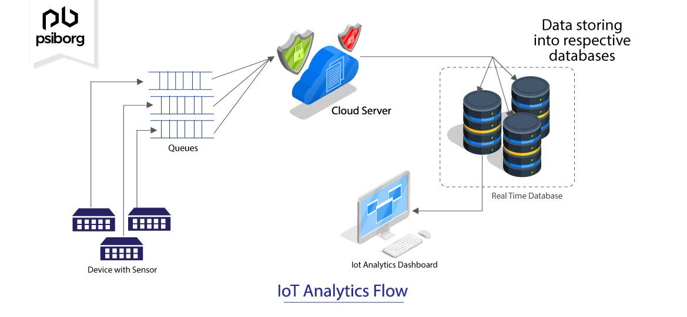

Figure 2.2: IoT Analytics Flow [60]

#### 2.6.2 IOT's relevance for detecting bacteria in water and its utility in detecting coliform

Water samples and the data that go with them are often processed and examined in laboratories. This may take a lot of time and effort and result in less trustworthy results. In light of the situation, it is essential to establish a suitable and organized system for continuous monitoring and management of water resources in order to address connected challenges. Internet of Things (IoT) enables the collection of real-time remote measurements which may be conducted with little to no human participation, providing a great alternative to conventional, complicated, and unsuccessful techniques for reaching this goal[61]. Due to the harmful health implications of consuming contaminated water, real-time monitoring of water quality is now required. IoT domain addresses this problem by providing creative and reasonably priced solutions for the problems of water contamination detection and water quality analysis[62].

The following are some benefits of using IOT for water quality monitoring:

1. Decreased cost of computing: The considerable amount of computing work, like that required by the Ubidots IoT-Platform, is handled by cloud servers. With the passage of this law, any widely used processor-based node (such as the NodeMCU (ESP32) kit) may be used in place of sophisticated microprocessors[63].
2. Hardly any human involvement:IOT systems can increase efficiency by reducing reliance on humans[64].
3. Low cost:IoT solutions are generally more cost-effective than traditional water monitoring techniques since they make use of currently in use, commercially available communication infrastructure, which is also more time-consuming[63].
4. Low power requirements:The local nodes only need to carry out minimal work after shifting the majority of the computing workload to the cloud server, and they can then primarily sleep. This made it possible to operate sensor nodes in far-off places with a little battery.
5. Real-time feedback delivery:The proper water authority and end users can both immediately receive real-time input from these systems via SMS, email, Twitter, Facebook, and other means[63].

### 2.7 Review of related works

This section analyzes experiments that involved the development of an improvised incubator for coliform growth in contaminated water samples as well as the identification of coliform and other types of bacteria in water using Internet of Things (IoT) technology. The next paragraphs concentrate on a few of the numerous research studies that have been carried out in this field.

A sensor-based Water Quality Monitoring System was employed in another study[52] to measure the water's molecular and physical properties, including its pH, temperature, turbidity, and Total Dissolved Solids. (TDS). The authors' IoT-based solution consisted of three crucial components: a multiparameter water quality analyzer, a means for information transmission, and a computer system unit. Sensors, Wi-Fi wireless transmission, an STM32 single chip microcontroller, and remote water quality monitoring were all included in the proposed system. The data on water quality collected were evaluated using ANOVA-based statistical analysis to identify the key causes of the river Krishna's deteriorating water quality. The authors used a water quality monitoring system based on the Internet of Things (IoT) to gather and evaluate current data on the river Krishna's water state in order to identify the primary causes of water contamination.

IoT-based technique for predicting bacterial contamination in water was proposed by the authors of a study paper[61]. The setup entails placing a variety of equipment in the study area, including sensors for determining total dissolved solids, pH level, turbidity, and dissolved oxygen. These tools are used to evaluate and keep track of the water's quality. These sensors transmit the data they have collected to a server using GSM modules, where it is processed and examined. The scientists used machine learning methods to predict coliform bacteria presence in the water based on the sensor data collected by the IoT system. The proposed approach provides a more useful and cost-effective alternative to manual lab analysis, which is an expensive and time-consuming process for the prediction of bacteria. To predict coliform presence bacteria in water, the authors created an IoT-based system that uses a variety of sensors and machine learning techniques, providing a quick and cheap alternative to traditional lab examination.

An incubator powered by batteries that effectively sustains a temperature range of approximately 35°C with a tolerance of ±1°C of 25°C for up to 65 hours is described in another study[65] free, open-source design. The objective of this incubator is to provide humanitarian engineers with a quick, simple, and visually pleasing method to evaluate the quality of microbes in water in remote locations. To confirm the presence of E. coli in the water samples, the authors used 3M Petrifilm E. coli/Coliform (EC) Count Plates. These dishes need to be incubated at a temperature that is in close proximity to body temperature. In order to meet this need, the portable incubator was developed, and the authors demonstrate that it can maintain the required temperature range for up to 65 hours. However, the use of IoT in the research is not acknowledged by the authors. As has been shown, IoT has the ability to improve water quality monitoring in various ways. Using temperature, pH level, dissolved oxygen, and turbidity as an example, Internet of Things (IoT) sensors can provide real-time information about these factors that affect water quality. This data may be sent to a database for adequate analysis and visualization, allowing for swift and educated decision-making. Additionally, IoT can allow remote water quality monitoring, doing away with the need for labor-intensive manual analysis.

In a different study, the writer used IoT to monitor and track the water quality in real-time[58]. They suggested a system that uses IoT sensors to measure pH, temperature, and turbidity in addition to other elements of water quality for use in homes. The system's objective is to offer remote internet access for managing and evaluating water purity, for instance through a mobile application. The proposed system uses Big Data Analytics and Machine Learning techniques to analyze water quality data in-depth, allowing the early detection of threats. In conclusion, the research's authors used IoT sensors and big data analytics techniques to measure and track water quality in real time, making it possible to identify risks early enough to prevent them and to manage water quality remotely.

In a different study[48], the authors developed a portable incubator for the development of coliform and E. coli germs using IoT technology. With the aid of this portable incubator, microbiologists can evaluate the quality of the water anywhere—not just in laboratories. Using qualitative and quantitative techniques, the incubator is able to identify E. coli in water samples as well as coliform bacteria. Two-factor authentication security enables real-time tracking, and the incubator can cut the detection period to just two hours. (2FA). The capability of the device to reach and maintain a predetermined temperature (typically 35–37°C) under various conditions, a procedure known as bacterial growth, determines the device's dependability. The incubation procedure can be carried out manually or automatically via Internet of Things (IoT) technology and computer vision. Data is protected by encryption techniques in the incubator, and the connection between the device and Wi-Fi is also secure. The outcomes of their experiment can also be observed in real time using IOT apps. In conclusion, the researchers developed a movable E. coli and coliform bacteria incubator using IoT technology that can identify the presence of these bacteria in water samples using both qualitative and quantitative techniques. Because it is dependable, secure, and can cut the detection time to just two hours, the incubator is an essential tool for microbiologists to use when conducting water quality checks all over the world.

In a different study[66], the authors describe a method for building a movable, affordable incubator for drinking water microbiological testing. The incubator prototype can be modified to handle different materials as well as volumes and has a disassemblabe design that makes carrying it easy. This may be used in grid-powered, laboratories as well as remote areas with solar or automobile batteries. The design uses components that are typically available, can work in a variety of outdoor settings, and maintains the advantages of more expensive laboratory-based models. In order to assess the microbes in drinking water, the writers wished to address the need for a portable, affordable incubator. A variety of culture-based microbiological techniques, including membrane filtration and culturing, are used to determine if water is fit for human consumption, can be used in the incubator. Overall, the authors' work suggests that their design may provide a practical and affordable alternative for the incubation of microbial colonies in the lab and the field. Their approach has the potential to be extensively applied in low-resource areas where it may be difficult to obtain specialized equipment. However, they did not incorporate any kind of IOT into their architecture.

The authors of another study [67] proposed a low-cost light detecting unit-based turbidity instrument for monitoring water cloudiness. The system makes use of an Intel Galileo 2 processor and a server for web-based tracking. The Turbidity Detection Unit is made up of a polyvinyl chloride (PVC) conduit, and a Light Emitting Diode (LED), a Light Dependent Resistor (LDR). The turbidity system relies on the idea that the amount of suspended matter and the amount of light it dissipates are directly correlated

The authors propose a clever Internet of Things (IoT)-based system for monitoring water quality indicators in another research publication [68]. The device is designed to monitor four physical water quality parameters: Turbidity, temperature, electric conductivity, pH. An Arduino microcontroller, Sensors, an ESP8266 Wi-Fi module, and a cloud database for data storage and analysis make up the proposed system. The device operates by using sensors to collect data from the water sample and transmit it to the Arduino. Using the ESP Wi-Fi module, data is analyzed by the microcontroller and sent to a cloud database. To furnish valuable insights into water quality, the collected data is saved and examined in the cloud database. The recommended system is effective and economical and can be used for real-time monitoring of water quality. The overall suggestion of the research paper is to put in place a smart water quality monitoring system that implements IoT to constantly track important water quality indicators. This technique can help reduce potential contamination exposure while ensuring the availability of clean potable water sources.

### 2.8 Summary

This study investigates ongoing and completed projects that are relevant to the subject at hand. By analyzing these projects, it has been possible to identify enhanced and more efficient approaches specifically related to the project being examined.

# CHAPTER THREE

## SYSTEM ANALYSIS AND DESIGN

### 3.1 Introduction

This section provides a comprehensive review of the materials, tools, and designs utilized to complete the development of the portable incubator. It offers a detailed explanation of the project's programming, circuit design, and construction methods, including a discussion of the components chosen and the reasoning behind those choices. The chapter also showcases the project's flowchart and algorithm and includes information on the methodology and calculation employed during the building process.

### 3.2 Components

This project employs three categories of components: electrical, mechanical, and chemical. The electrical components encompass a Light Dependent Resistor (LDR), a DHT11 temperature and humidity sensor, a relay, an ESP32 microcontroller, an LED bulb, a 220-12V (AC-DC) power adapter, a buck converter, a Liquid Crystal Display (LCD), and a potentiometer. The mechanical components consist of the incubator and the beakers utilized for holding the water samples under investigation. The chemical component pertains to the substrate named water detect coliform.

#### 3.2.1 ESP 32

The ESP 32 is an affordable microcontroller that has Wi-Fi and dual-mode Bluetooth built-in. It acts as both the microcontroller and Wi-Fi module, controlling the relay switch and interfacing with sensors. When connected to a Local Area Network (LAN), it enables real-time access to readings through the Blynk platform.

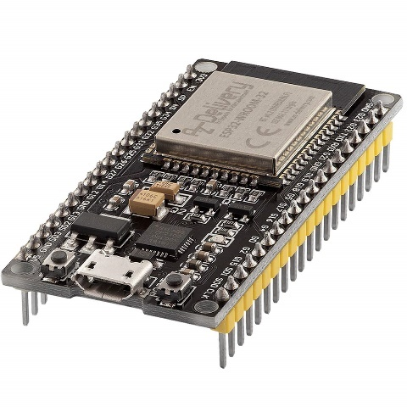

Figure 3.1: Expressif Systems Processor (ESP) 32

#### 3.2.2 Light Dependent Resistor (LDR)

This is also known as a photo resistor, photocell, or photoconductor, is a sensor that responds to light changes by altering its resistance. When light falls on an LDR, its resistance changes. The light intensity reaching the LDR is inversely proportional to its resistance. The LDR is used to detect the turbidity levels of the water sample being tested. Due to the water sample being clear initially, more light reaches the LDR, causing a decrease in its resistance. However, if the water sample contains coliform bacteria, after approximately 16 hours of incubation, it turns blue. As a result, the LDR receives less light, causing an increase in its resistance value.

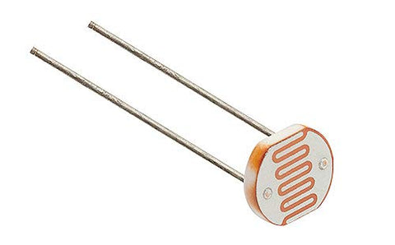

Figure 3.2: Light Dependent Resistor (LDR)

#### 3.2.3 Relay

A relay is an electronic device that can be switched on or off when an external voltage (AC or DC) is applied across its control terminals. In this project, the relay is utilized to control the heating pad, which helps maintain the desired temperature range of 35-37℃ inside the incubator. The heating pad is connected to the relay, which is in turn connected to the ESP32. The ESP32 turns the relay on or off based on the temperature readings obtained from the DHT11 sensor, thereby regulating the temperature inside the incubator.

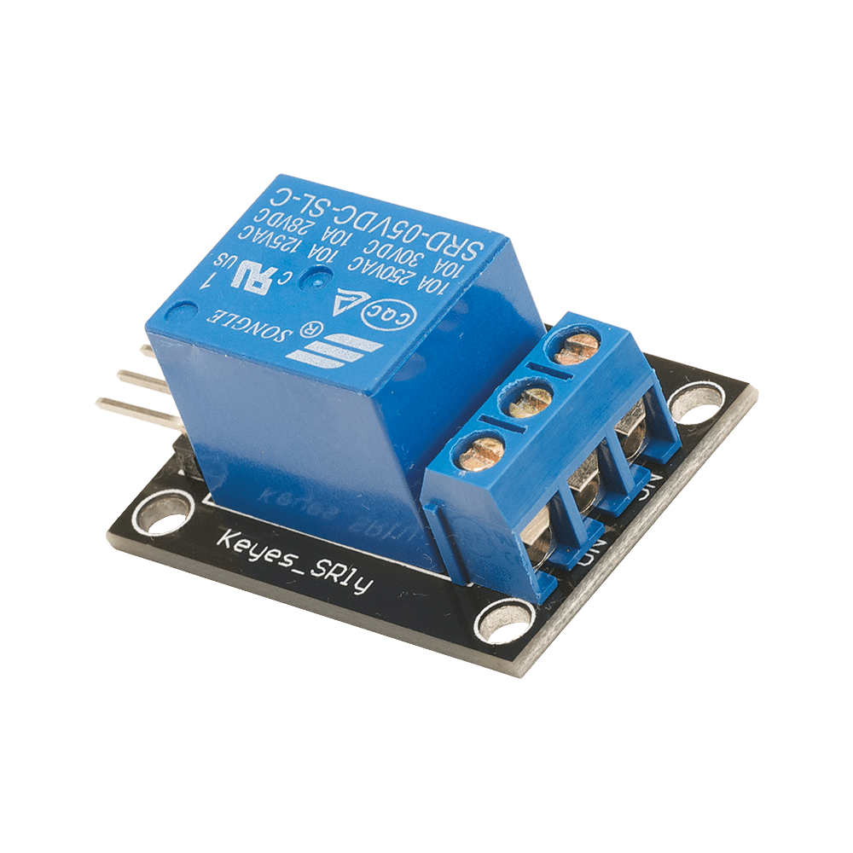

Figure 3.3: Relay

#### 3.2.4. DC-DC Buck Converter

A DC-DC converter is an electronic device that can increase or decrease voltage of a direct current power source to match a desired voltage level. In this project, a 5V buck converter is used to step down the voltage from the 220V AC to 12V DC power adapter to the 5V level needed to power the various components of the system.

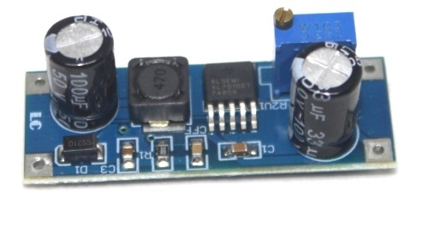

Figure 3.4: DC-DC Buck Converter

#### 3.2.5 PTC Electrical Heating Element

The incubator utilizes an electrical heating pad as its source of heat, which is controlled by the relay. The relay is triggered on and off by the microcontroller, depending on the temperature readings from the DHT11 sensor. The heating pad plays a crucial role in maintaining the temperature range required for the coliform bacteria's optimal growth in the water samples, which is between 35-37℃.

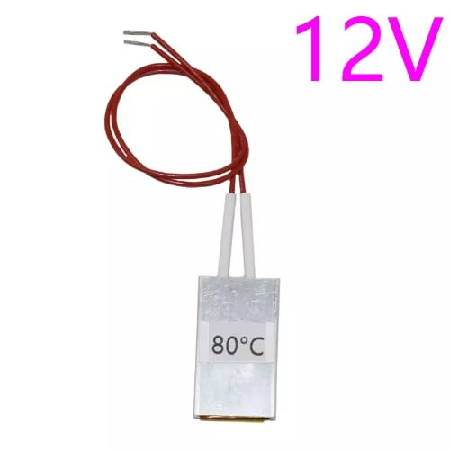

Figure 3.5: Heating Source

#### 3.2.6 LED Bulb

The LED bulb is used as the lighting source. It supplies the LDR with the sufficient light required to determine the turbidity levels of the water samples.

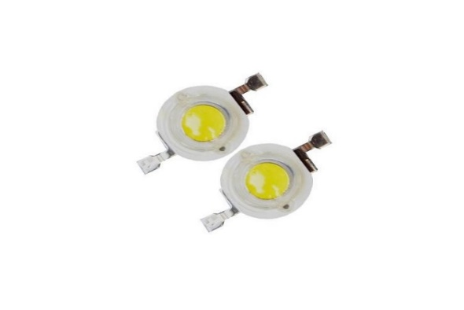

Figure 3.6: LED Bulb

#### 3.2.7 DHT11 Temperature and Humidity Sensor

The DHT11 sensor is utilized to obtain data on the temperature and humidity levels within the incubator. Its significance lies in ensuring that the temperature remains within the 35-37℃ range. The ESP32 is connected to this sensor for interfacing purposes.

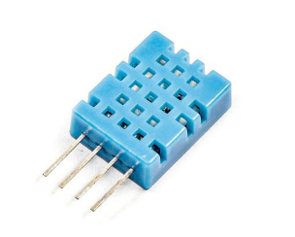

Figure 3.7: DHT 11

#### **3.2.8 Liquid Crystal Display (LCD)**

For this project, a 20x4 (20 characters, 4 rows) LCD display is utilized to provide a user-friendly interface for monitoring real-time data readings from various sensors. The LCD display effectively shows temperature and humidity levels within the incubator, as well as the resistance readings of the Light Dependent Resistors. It is interfaced with the ESP32 microcontroller to display the data readings on the screen. The real-time data presented on the LCD enables users to monitor the progress of the incubation process and ensure the optimal conditions necessary for the growth of coliform bacteria.

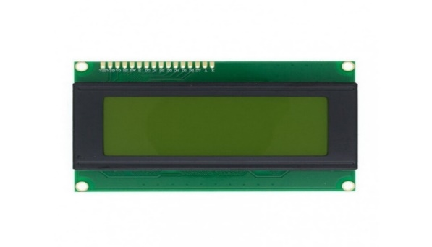

Figure 3.8: Liquid Crystal Display

#### 3.2.9 I2C Serial Interface Adapter Module

The LCD 20x4 display used in this project is connected to the ESP32 microcontroller using I2C communication protocol. This allows for a simpler and more efficient data transfer between the microcontroller and the LCD display. The I2C interface reduces the number of pins required for communication, making it easier to interface with other components in the project.

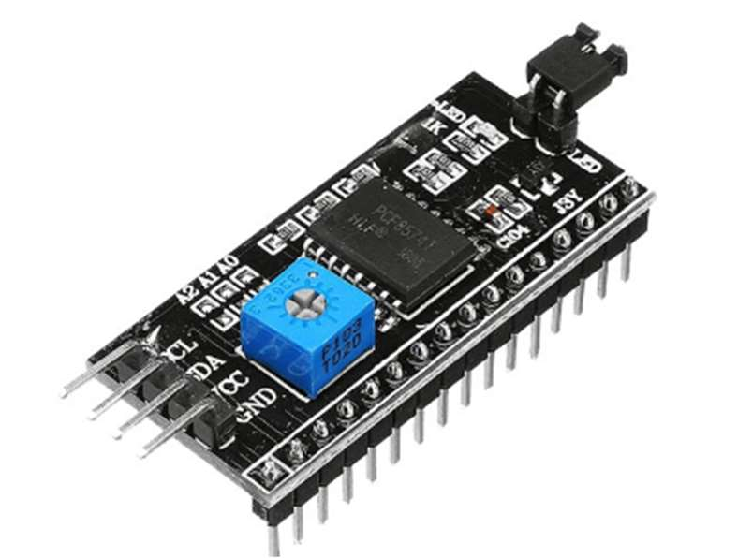

Figure 3.9: I2C Serial Interface Adapter Module

#### 3.2.10 Incubator

The incubator is an essential tool in detecting Coliform bacteria in water samples. Its importance lies in its ability to provide a controlled environment that promotes the growth of Coliform bacteria, necessary for their detection. The incubator ensures accurate and reliable results by maintaining constant temperature and humidity conditions, reducing the risk of false negatives. Additionally, the use of an incubator provides a standardized procedure for Coliform detection in water, allowing for consistent comparison of results across various samples and testing centers. In summary, the incubator is a critical component in the detection of Coliform in water, offering a dependable and consistent method for bacteria growth and detection.

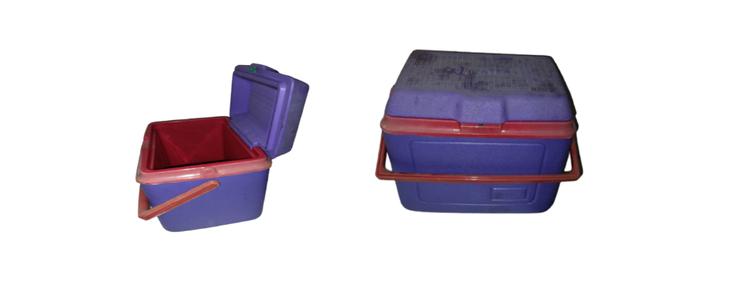

Figure 3.10: Incubator

#### 3.2.11 Beaker

The beakers are utilized to contain the water samples for testing. They are transparent and enable light to pass through the water sample to the LDR. Additionally, they have markings that allow for accurate measurement of the volume of water being tested in milliliters (ml).

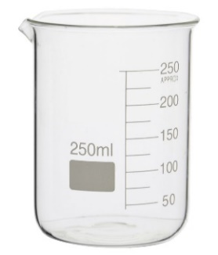

Figure 3.11: Beaker

#### 3.2.12 Water Detect Coliform Powder

The chemical being used for detecting coliform bacteria in water samples is a crucial component of our project. It is the only substance capable of detecting the presence of coliforms, which generate acids and gases through β-galactosidase enzyme activity at their optimal growth temperature of 35-to-37-degree Celsius(°C). The chemical works by breaking down a chromogenic or fluorogenic substrate, resulting in the production of color or fluorescence. Specifically, the powder changes the color of water samples from a clear and transparent appearance to a dark greenish hue, indicating the presence of coliforms. This color change is important for our project as it allows the Light Detecting Resistors to detect a decrease in light intensity when the water changes color, which indicates the presence of coliforms in the sample.

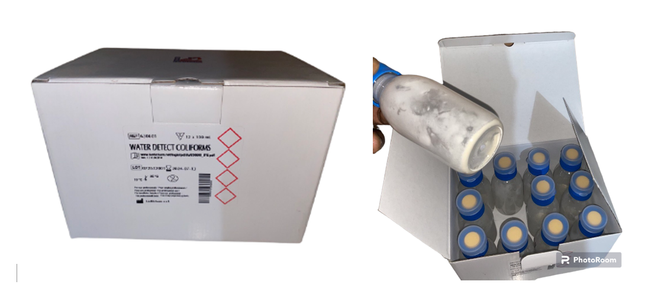

Figure 3.12: Water Detect Coliform Powder

#### 3.2.13 Power Supply Adapter

The incubator's components are powered by a power supply adapter, which includes a rectifying circuit that converts a 220V AC power supply to a 12V DC power supply suitable for our components.

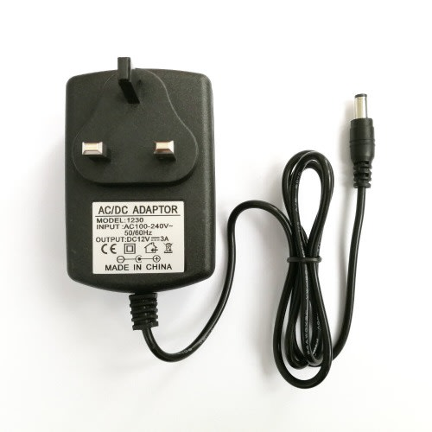

Figure 3.13: Power Supply Adapter

#### 3.2.14 10k resistors

In order to convert the resistance reading of the LDR into a measurable voltage signal, we can create a voltage divider circuit by combining the LDRs with fixed resistors. This circuit allows us to obtain a proportional voltage output corresponding to the LDR resistance, which can then be accurately measured by the ESP 32

Additionally, when using the DHT11 sensor, it can be utilized as a pull-up resistor. The purpose of the pull-up resistor is to prevent the pins from floating in an undefined state. By providing a defined state to the resistor, we ensure consistent and reliable data transmission and reading from our respective sensors.

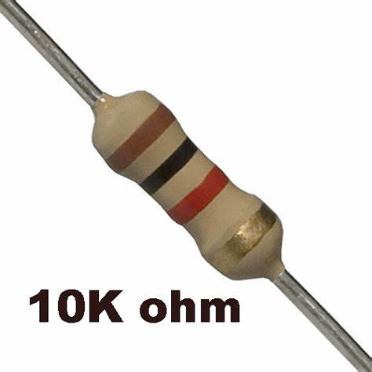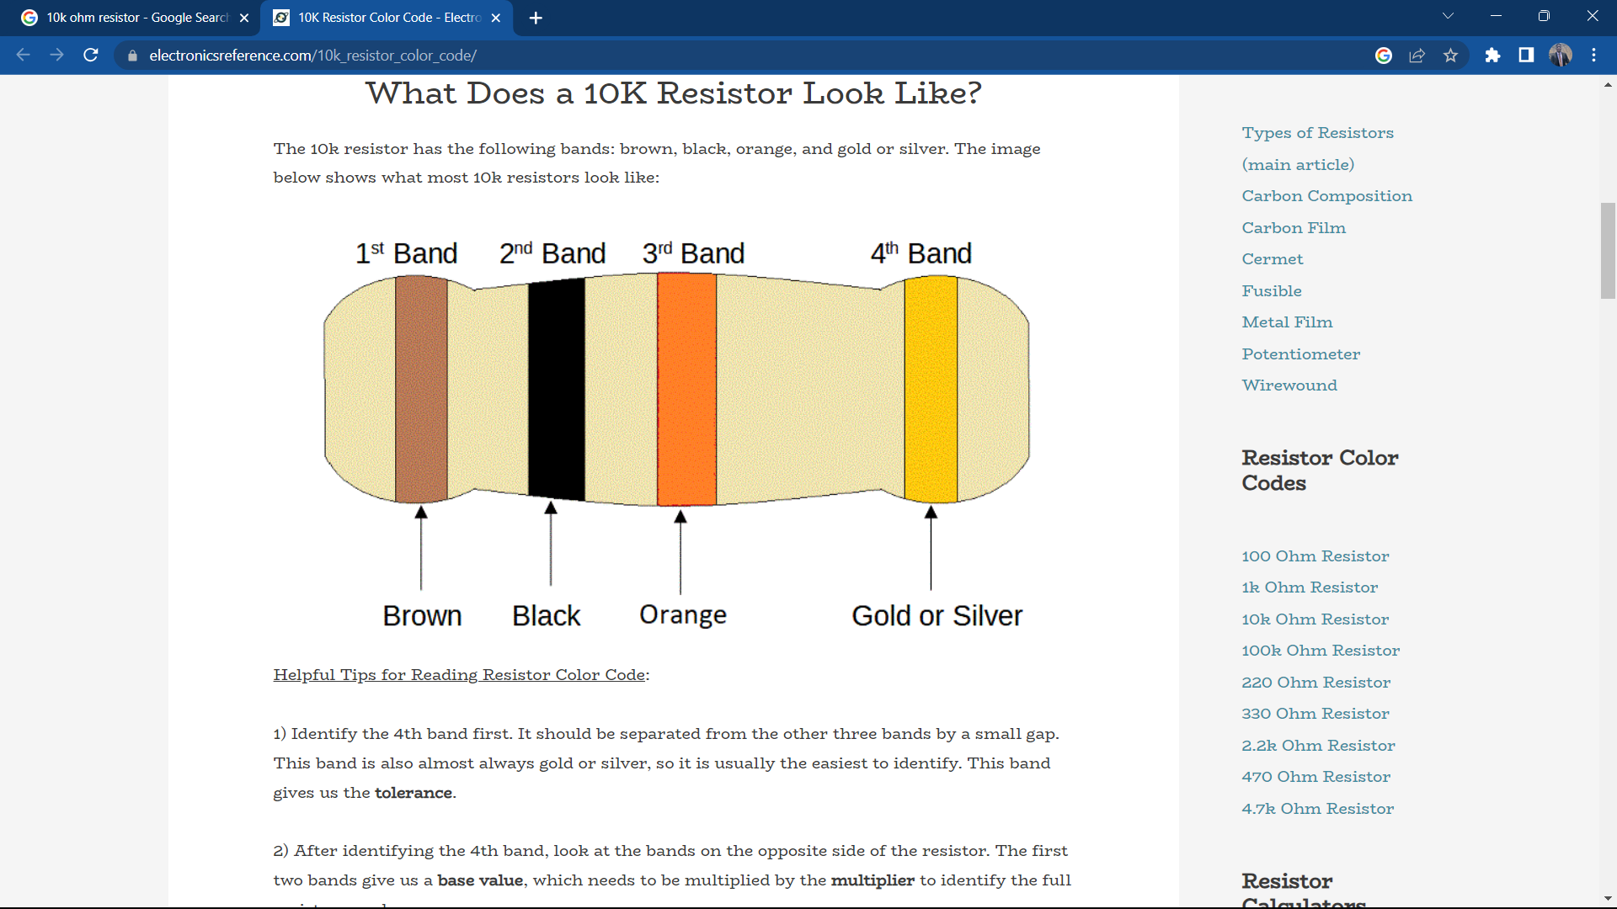

Figure 3.14: 10k resistors

#### 3.2.15. Polyethylene foam

This consists of a thermoplastic polymer that is lightweight in nature. Its purpose is to enhance the thermal efficiency within the incubator by providing excellent thermal insulation characteristics. The foam is applied to both the walls and the base of the incubator, acting as padding.

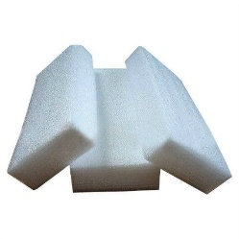

Figure 3.15: Polyethylene foam

### 3.4 Description of Software Requirements

The programming of the entire system will be done using the Arduino C/C++ language on the Arduino Integrated Development Environment (IDE), followed by compilation and uploading to the microcontroller. The software required for this project is outlined below.

#### 3.4.1 Arduino Integrated Development Environment (IDE)

This software is open-source and streamlines the process of programming and uploading code to the microcontroller board. It can be used on different operating systems such as Windows, Mac OS X, and Linux. The user interface was developed using Java and free and open-source tools like Lua Processing. Our project's Arduino board programming is written in C++, and the IDE software translates our readable human program codes into machine language. Before uploading to the microcontroller board, the IDE checks the source code for errors to ensure proper functionality.



Figure 3.16: Arduino Integrated Development Environment (IDE)

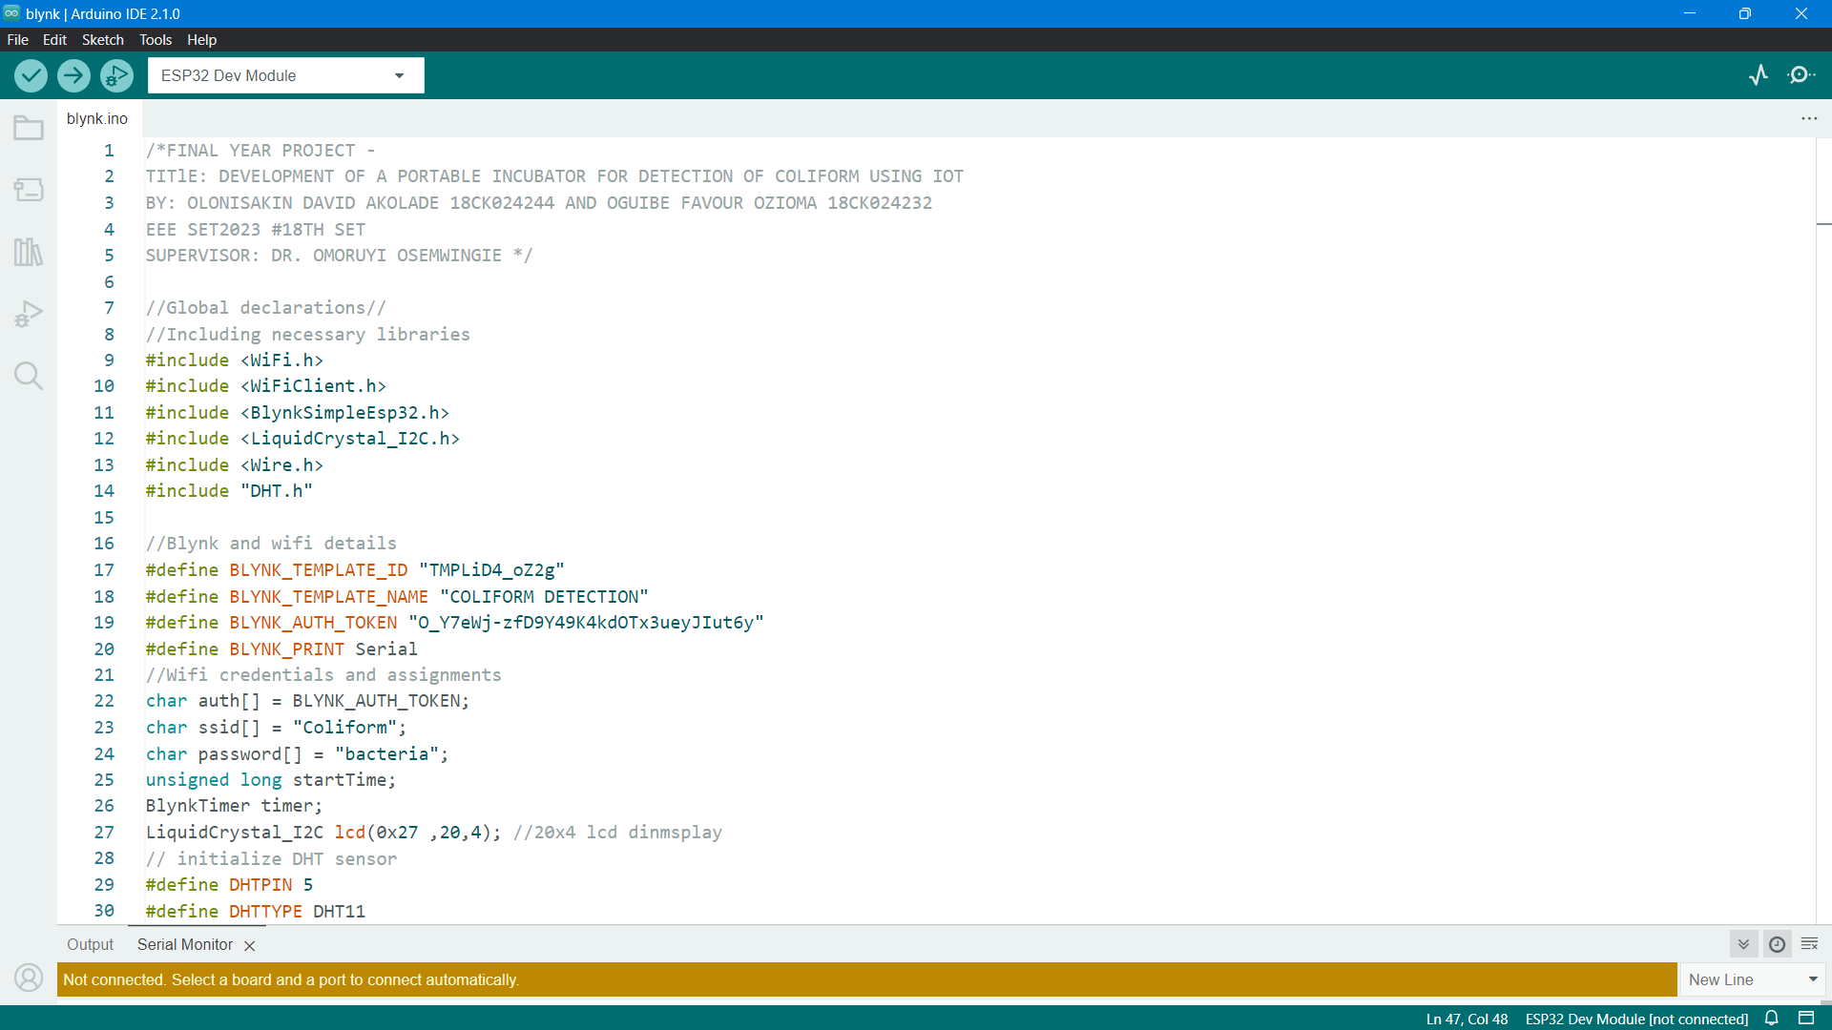

Figure 3.17: Arduino Integrated Development Environment (IDE) Code Snippet

#### 3.4.2 Blynk

Blynk is a versatile platform that enables users to create mobile applications that control and monitor devices over the internet. One of the key advantages of Blynk is its user-friendly interface, which makes it easy for users to monitor and control various IoT devices from their smartphones. In this particular project, Blynk offers a significant role in facilitating remote monitoring of the incubator's temperature and water quality parameters using a mobile device.

By integrating the ESP 32 with the Blynk platform, users can remotely monitor the temperature of the incubator and the water quality parameters in real-time. Blynk also allows users to set up alerts and notifications that can be sent to their smartphones if the temperature or water quality parameters fall outside the acceptable range. This feature ensures that users can respond quickly to any deviations from ideal conditions and prevent damage to the organisms being cultured in the incubator.

In summary, Blynk's user-friendly and convenient interface makes it an ideal platform for remotely monitoring and controlling the incubator's temperature and water quality parameters. By using Blynk in conjunction with the ESP 32, users can ensure that optimal conditions are maintained for the organisms being cultured in the incubator.

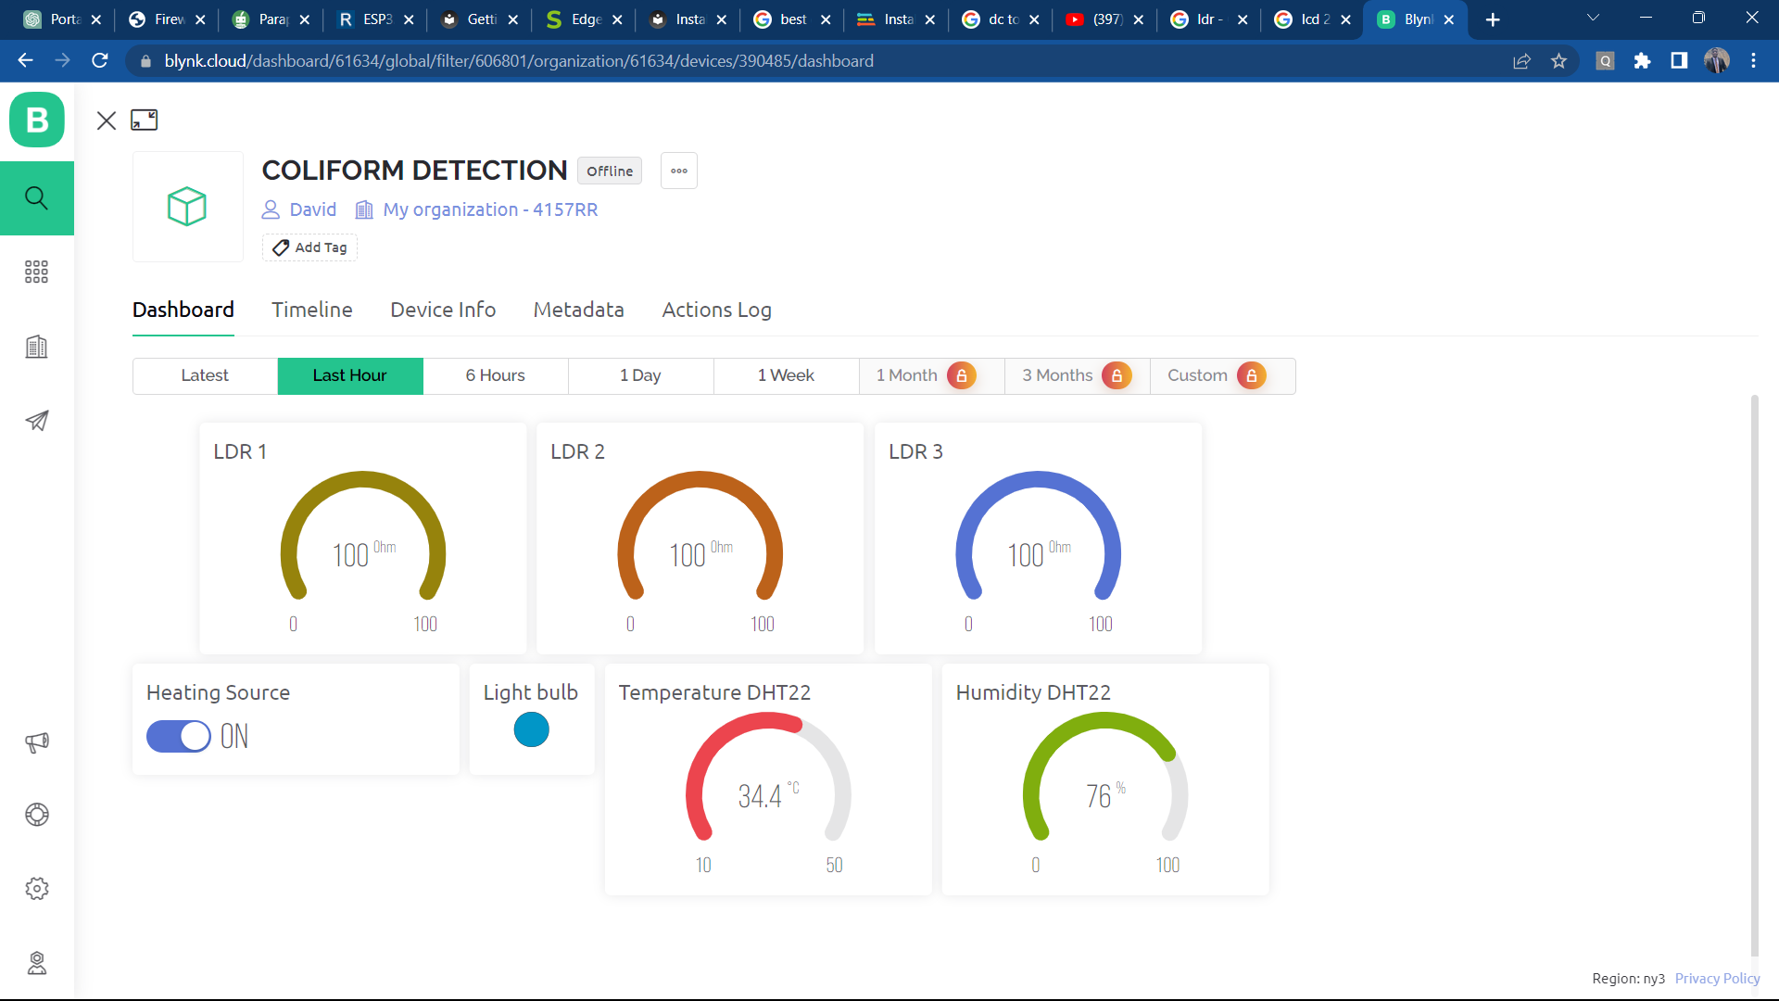

Figure 3.18: Blynk Application

### 3.3 Design specification

#### 3.3.1 Systems Block Diagram

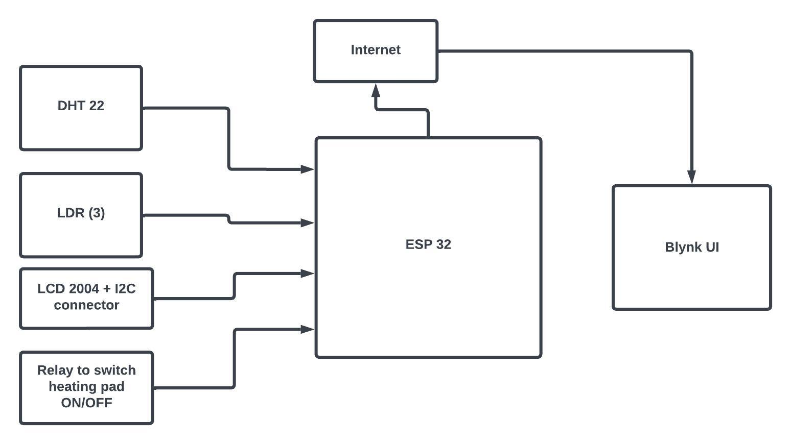

Figure 3.19: Systems Block Diagram

#### 3.3.2 Circuit Diagram

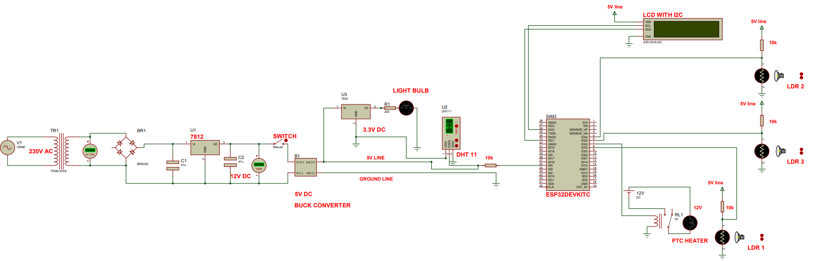

Figure 3.20: Circuit Diagram

#### 3.3.3 Systems Algorithm

The project's algorithm is the series of procedures taken to solve the problem with code and create a working system. The following actions were conducted in the following order according :

1. Initialize the portable incubator system.
2. Set up the light-dependent resistor (LDR) sensor and connect it to the microcontroller (ESP32).
3. Connect the Digital Humidity and Temperature (DHT11) sensor and the heating element to the microcontroller.
4. Configure the incubator system to maintain a temperature range of 35-37°C for optimal coliform bacteria growth.
5. Display the resistance and temperature readings on the Liquid Crystal Display (LCD) screen.
6. Collect water samples to be tested for the presence of coliform bacteria.
7. Place the water samples in the incubator system and close it to create a controlled environment.
8. Activate the LDR sensor to detect changes in turbidity, indicating the presence of coliform bacteria.
9. Continuously monitor the resistance readings from the LDR sensor.
10. If the resistance readings indicate a significant change in turbidity, record the data.
11. Use the DHT11 sensor and heating element to maintain the appropriate temperature during the incubation process.
12. Continuously monitor the temperature inside the incubator system.
13. Transmit the collected data from the microcontroller to the Blynk application for real-time monitoring and analysis.
14. Ensure the data transmission to the Blynk application is successful.
15. Analyze the data in the Blynk application for coliform bacteria detection and monitoring.
16. Provide alerts or notifications through the Blynk application if coliform bacteria presence is detected.
17. Repeat the process for each water sample, allowing for continuous monitoring and analysis.

#### 3.3.4 Systems Flowchart

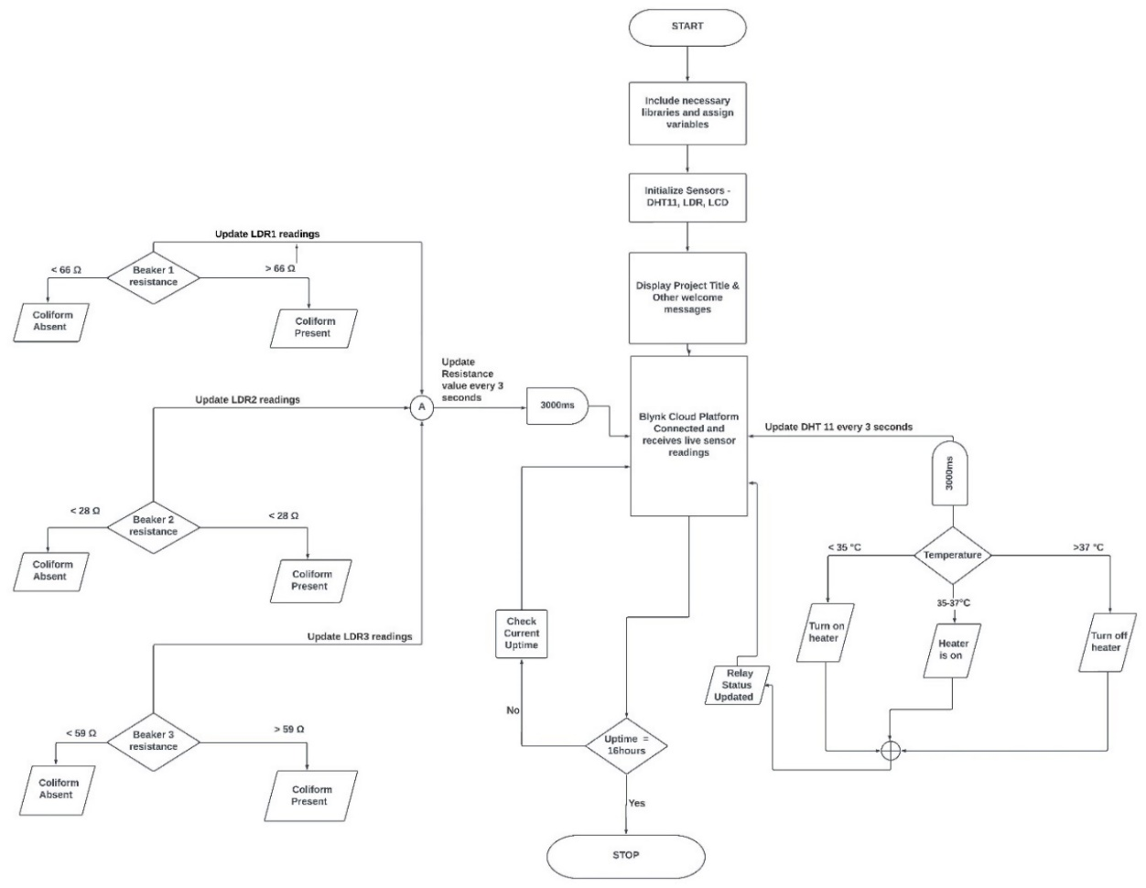

Figure 3.21: Systems Flowchart

#### 3.3.5 Electrical Calculations

**Heat transfer calculations**

In order to determine the suitable power rating for the heating element necessary in the incubator, it is crucial to take into consideration the amount of heat energy required to elevate the temperature of both the water and air within the incubator to the desired level. By utilizing the specific heat capacity formula,

$$Q=m×c×∆θ 3.1$$

Where:

Q is the amount of energy (in joules)

m is the mass of water (in kilograms)

c is the specific heat capacity of water (in J/kg.k)

∆𝛉 is the change in temperature (in kelvin, K)

There are three beakers in total, each containing 100ml of water, making a total of 300ml. Converting 300ml to mass gives:

$$Density=\frac{Mass}{Volume} 3.2$$

$$Mass=Density×Volume 3.3$$

Density of water = 1g/cm3 or 1g/ml, therefore, mass of water in incubator = 1g/ml x 300ml = 300g or 0.3kg

The specific heat capacity of water is approximately **4190J/kg.k** Assuming the initial temperature of the water is room temperature **20°C (293k),** and we want to raise it to 37°C (310k), ΔT would be **17kelvin**. Therefore, the heat energy required to raise the temperature of 100ml of water is:

**Q = 0.1 kg * 4190J/kg.k * 17k = 7.123kJ**

Since there are three beakers, the total heat energy required to raise the temperature of all the water is:

**Q_total = 3 x 7.123kJ = 21.369kJ**

In addition to the water, it is important to factor in the heat energy needed to increase the temperature of the air inside the incubator. To determine the quantity of heat energy required for raising the temperature of a given volume of air, the following equation can be employed:

**Q = m x cp x ∆𝛉**

Where:

m = mass of air

**cp =** Specific heat capacity of air

∆𝛉 = change in temperature

The incubator has internal dimensions of 270mm x 140mm x 200mm. Therefore, volume of incubator = Length x Breadth x Height = 0.27m x 0.14m x 0.2m = **0.00756m3.** We need to raise the temperature inside the incubator from 20℃ (293k) to 35℃ (308k). ∆𝛉 will be **(308k – 293k = 15kelvin)**. The mass of air can be calculated using the density of air **(**approximately 1.28 kg/m3**)** and the volume of the incubator:

$$Density=\frac{Mass}{Volume} 3.2$$

$$Mass=Density×Volume 3.3$$

m = 1.28 kg/m3 * 0.00756m3 **= 0.009677kg**

The specific heat capacity of air is approximately **1005 J/kg·K**. Therefore, the heat energy required to raise the temperature of the air inside the incubator is:

**Q = 0.009677kg * 1005 J/kg·K * 15 = 145.88J**

The following amount of heat energy is needed overall to raise the temperature of the water and air inside the incubator:

**Qtotal = 21.369kJ + 145.88J = 21.514kJ**

To calculate the power rating required for the PTC heating element, we also need to consider the time it takes to raise the temperature. Let's assume we want to raise the temperature in 20 minutes or 1200 seconds. Therefore, the power rating required for the PTC heating element is gotten by using the formula

$$Q_{total}=pt 3.4$$

$P=\frac{Q_{total}}{t}$ = 21.514kJ / 1200 **=** 17.9 watts $≈$**18 watts**

Hence, a PTC element rated for about **18watts** will be sufficient to raise the ambient temperature in the incubator to 35-37℃ in 20 minutes. A lower rating heating element could alternatively be used, as the polystyrene foam used to pad the walls of the incubator will enhance insulation.

Table 3.1: Component Voltage and Current Values

|  |  |  |
| --- | --- | --- |
| Component | Voltage Draw | Current Draw |
| ESP 32 | 5v | 240mA |
| Relay | 5v | 160mA |
| Liquid Crystal Display (LCD) | 4.5v - 5.5v | 120mA |
| Heating Element | 12v | 1670mA |
| LED Bulb | 3.4v | 350mA |
| DHT 11 | 3.3v – 5.5v | 2.5mA |

Hence, total current draw = (240 + 160 + 120 + 1670 + 350 + 2.5) mA = 2542.5mA

Therefore, a power adapter rated at least 3amps is needed.

### 3.5 Conclusion

This section provides a detailed overview of the construction process of this project. It explains in detail the different components utilized, the circuitry, block diagrams, algorithms, and flowcharts employed. Moreover, it describes the architecture and techniques of the system, giving practical examples. The chapter also outlines the implementation procedures, including the proposed model and the development approach to be followed.

# CHAPTER FOUR

## RESULTS AND DISCUSSIONS

### 4.1 Introduction

This chapter presents the outcomes and analysis of the project, focusing on significant discoveries and observations made during the implementation and testing phases. The primary objective of the project was to develop an incubator system that could detect coliform in water by controlling temperature and humidity within a predetermined incubation period. To accomplish this, the incubator utilized several components, such as an LDR sensor, a DHT sensor, a PTC heating element, an ESP 32 , and the Blynk IoT platform.

The chapter details the interconnection of the hardware components and provides a step-by-step account of calibrating the LDR sensor. Accurate readings from these sensors are crucial for drawing meaningful conclusions. It also covers the configuration of the PTC heating element and the integration of the hardware components with the Blynk platform.

Moreover, comprehensive testing of the individual subunits forming the complete system was conducted to identify any design flaws that might have arisen during the project's construction. The testing phase aimed to ensure the proper functioning of the system while rectifying any potential errors.

### 4.2 Hardware Implementation

The interior structure of the incubator and the connectivity of all project-related components are both crucial aspects. To ensure optimal thermal insulation, the inside walls of the incubator were lined with polyethylene foam. This choice was made because polyethylene foam possesses excellent properties for thermal insulation. Its low thermal conductivity effectively inhibits heat transfer, minimizing heat loss to the surroundings. By implementing this insulation, the energy needed to maintain the desired temperature range is reduced, allowing for a consistent and regulated interior temperature.

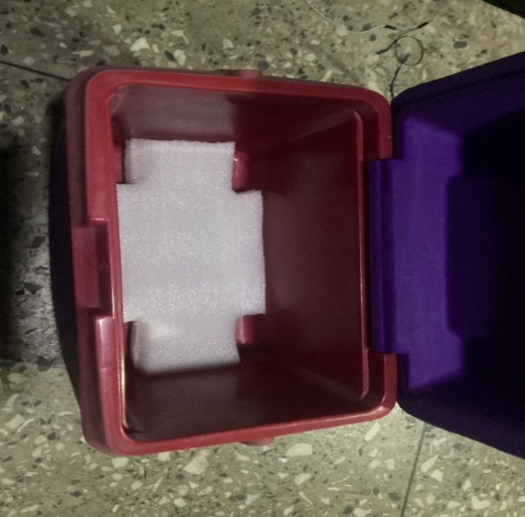

Figure 4.1: Inside of incubator with base padded with polyethylene foam

To provide padding for the base of the incubator, approximately four layers of foam were applied. The foam was carefully cut along the edges to allow for the insertion of the legs of the beaker stand.

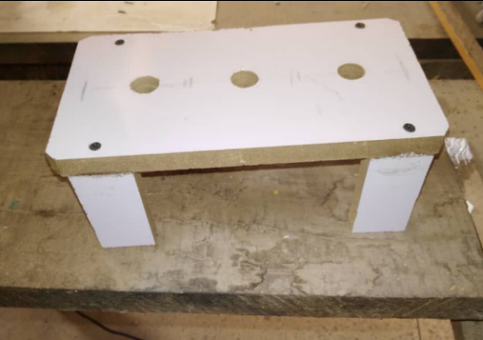

Figure 4.2: Beaker stand

In order to expose the LDRs (Light Dependent Resistors) to the light emitted by the LED bulb, holes were drilled into the stand. Additionally, a hole was created on the side of the incubator to allow the wires to pass from the interior to the exterior. These wires were then soldered to the other components through the use of a Vero board. To ensure the desired temperature inside the incubator was maintained, the hole was carefully sealed using hot glue applied with a glue gun.

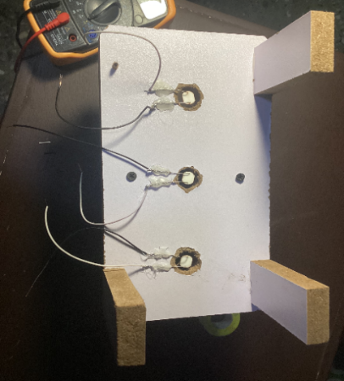

Figure 4.3: LDR legs attached to base of beaker

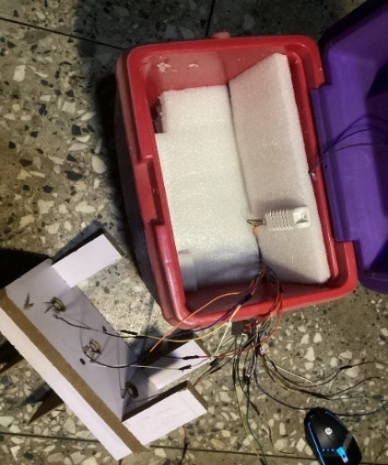

Figure 4.4: Internal image of incubator showing wiring to the outside

#### 4.2.1 DHT 11 sensor and PTC heating element testing

The DHT sensor is of great importance as it provides accurate measurements of temperature and humidity within the incubator. Maintaining a temperature range of 35-37℃ is essential for optimal growth of coliform bacteria in the water samples. The DHT sensor consists of three pins: a signal pin, a Vcc pin, and a ground pin.

To establish a reliable data connection, the signal pin is connected to a pull-up resistor and then to the ESP32 microcontroller. In the code, the DHTPIN is assigned the value of 5, representing the specific GPIO pin number on the ESP microcontroller to which the data pin of the DHT11 sensor is connected. This GPIO 5 pin serves the purpose of receiving data from the DHT11 sensor.

The presence of a pull-up resistor is necessary to ensure the reliability of the received data signal. When the DHT11 sensor is not actively transmitting data, the data line may be left floating or uncertain, leading to potential data errors. By utilizing a pull-up resistor, the data line is maintained at a defined, fixed voltage level, providing stability and eliminating the impact of external disturbances.

Furthermore, the constant DHTTYPE is defined as DHT11, indicating the specific type of sensor being used. To interact with the DHT11 sensor, an instance of the DHT class named dht is declared using the constructor DHT dht(DHTPIN, DHTTYPE). By passing the previously defined constants as arguments, the dht object is properly configured to communicate with the DHT11 sensor connected to GPIO pin 5.

In summary, this setup ensures the ESP microcontroller effectively retrieves temperature and humidity data from the DHT11 sensor, facilitating the monitoring of the incubator environment.

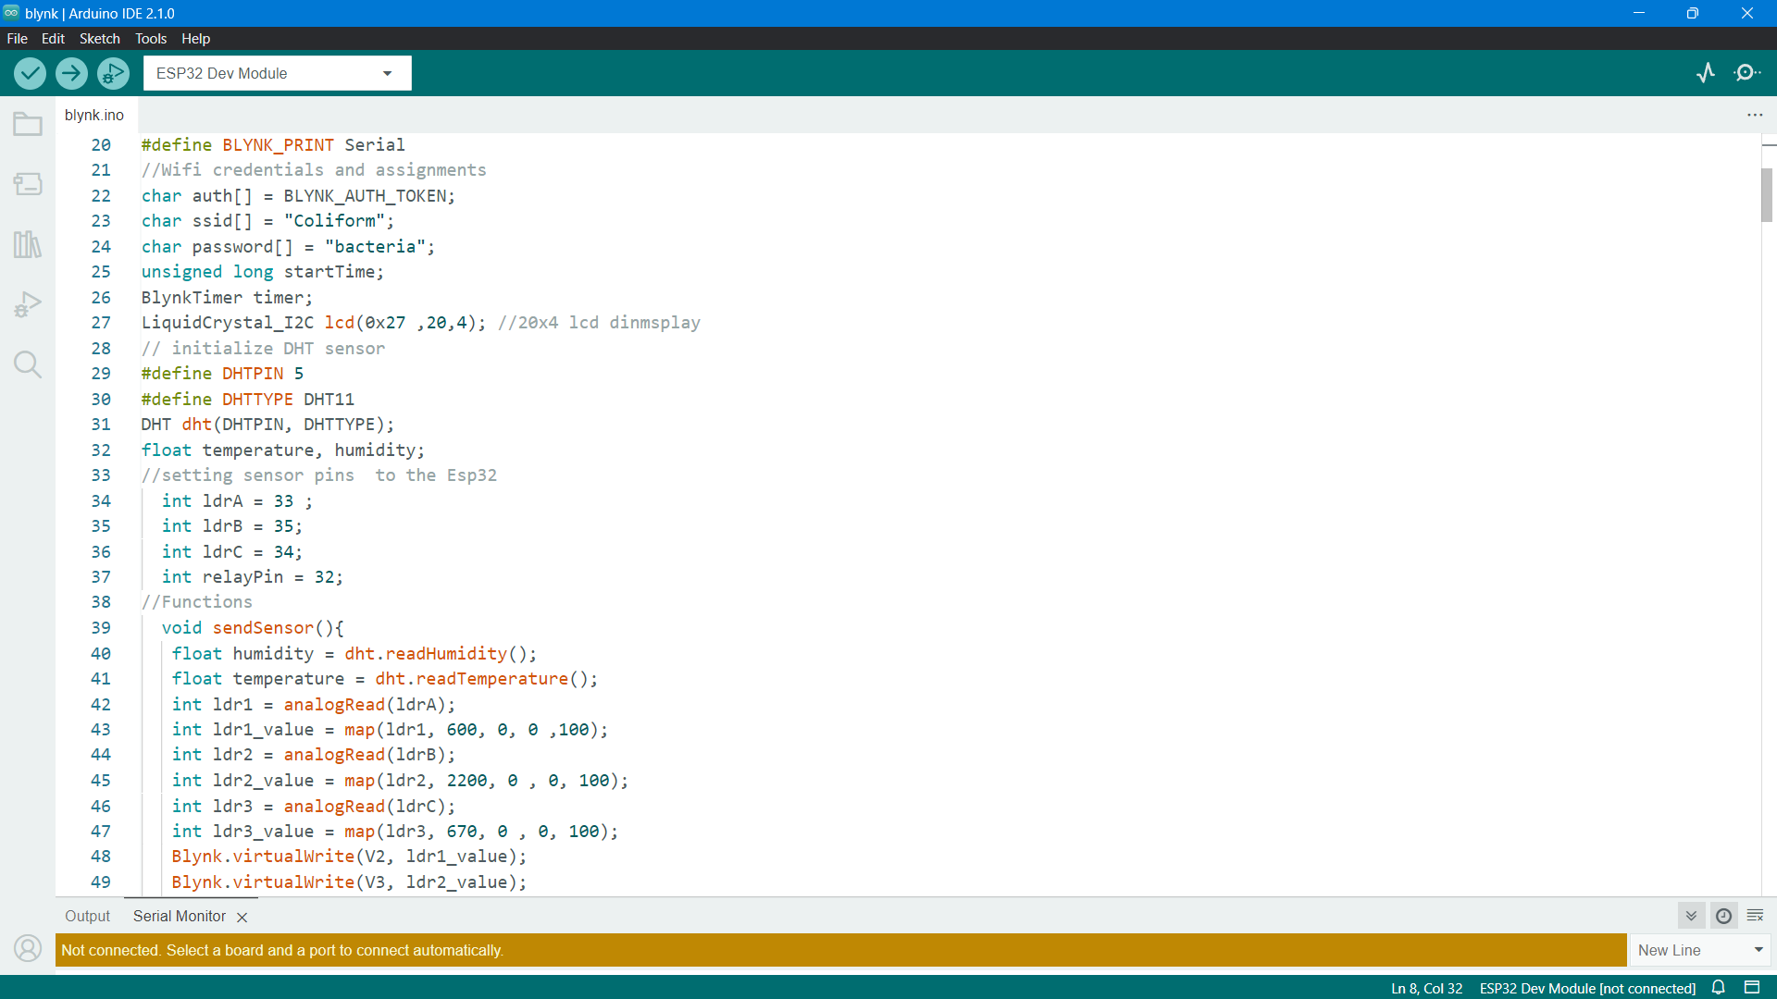

Figure 4.5: DHT pin configuration

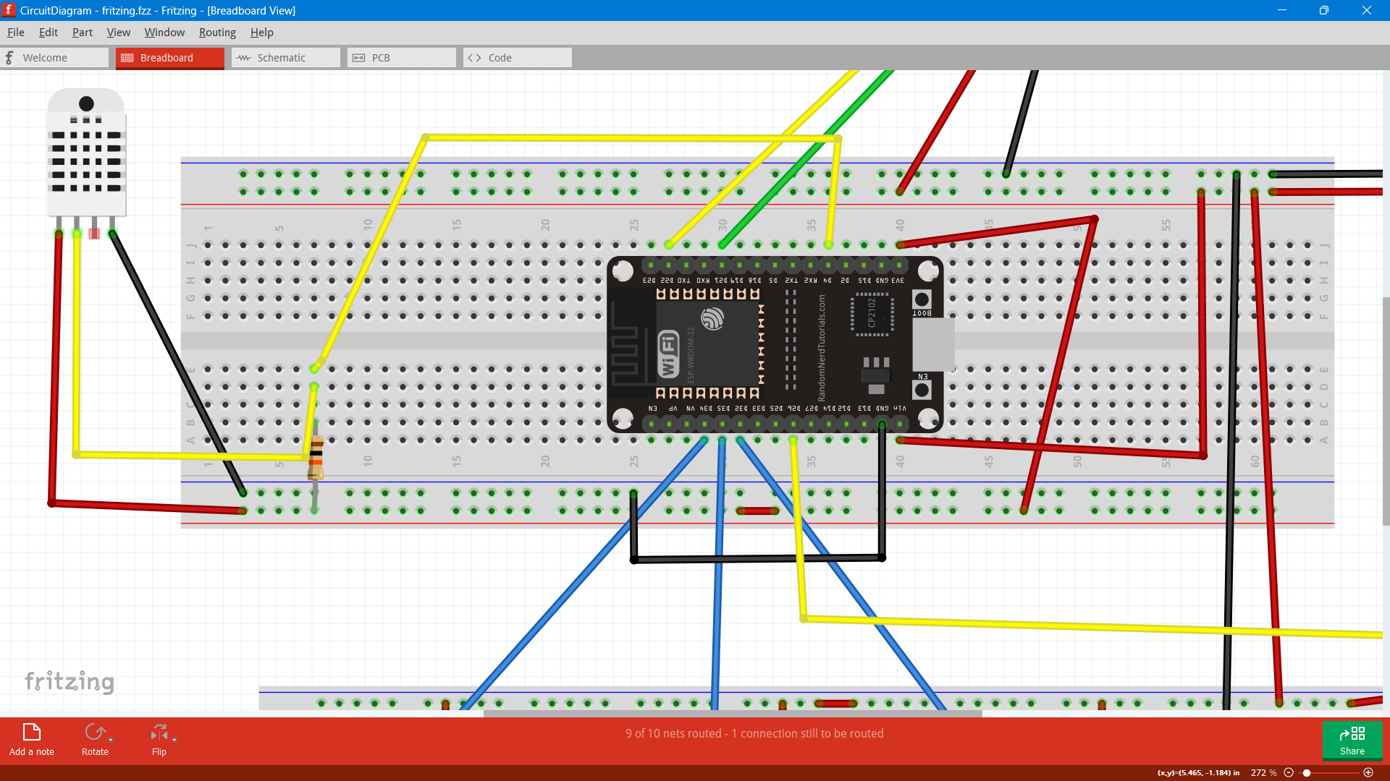

Figure 4.6: DHT 11 to ESP32 wiring diagram

#### 4.2.2 Relay and PTC heating element connection

The heating element utilized in the system is equipped with only two wires, and they do not possess any polarity. The operation of the heating element is not reliant on the direction of electric current flow. Instead, it operates based on its electrical resistance characteristics. One wire of the heating element is connected to the ground, while the other wire receives power from the relay.

In this specific case, a single-channel relay is employed, as it is solely required for controlling the heating element. The relay consists of six pins. On one side, there is a signal pin, a Vcc pin used to supply power to the relay, and a ground pin. On the other side, there are a normally open pin, a normally closed pin, and in the middle, a common contact point. These pins facilitate the relay's functionality in managing the electrical connection to the heating element.

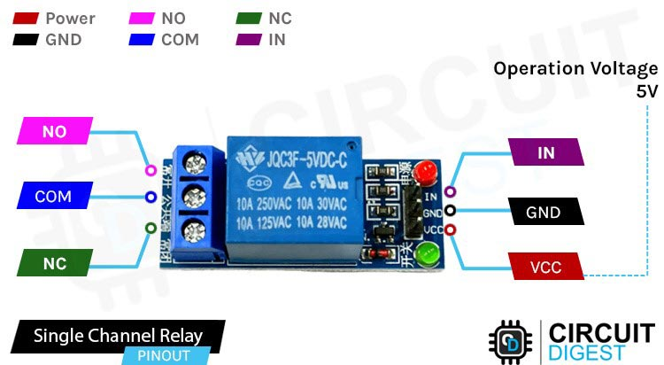

Figure 4.7: Single Channel relay pin-out Diagram

To power the relay, the Vcc pin is connected to the 5V supply, while the ground pin is connected to the ground line. The objective is to keep the PTC heating element activated until the temperature inside the incubator reaches 37℃. For this purpose, one leg of the PTC heating element is connected to the normally closed pin of the relay, while the other leg is connected to the ground line. Since the heating element requires a 12V supply, the 12V supply is connected to the common contact point on the relay.

The signal pin of the relay is connected to the ESP32 microcontroller. When the DHT sensor sends a signal to the ESP32, indicating that the temperature inside the incubator has exceeded 37℃, the ESP32 responds by sending a high signal to the relay. This high voltage signal triggers an internal mechanism within the relay, such as an electromagnet or solid-state component, causing the relay to change its state. Consequently, when the relay is triggered, it opens the circuit between the Common (COM) and normally closed (NC) pins, effectively interrupting the power supply to the PTC heating element and turning it off.

Once the temperature drops below 35℃, the ESP32 sends a low signal to the relay, prompting it to close the circuit between the common point and the normally closed pins. This action triggers the relay to turn back on, subsequently restoring power to the heating element. This cycle ensures that the PTC heating element remains active when the temperature is below 35℃ and is deactivated when it reaches 37℃, thereby regulating the temperature inside the incubator.

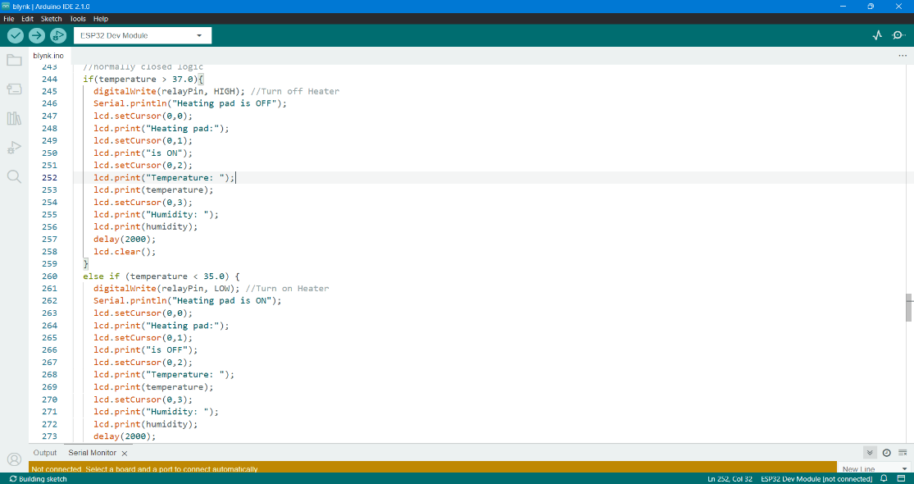

Figure 4.8: Image of code showing heating element conditions

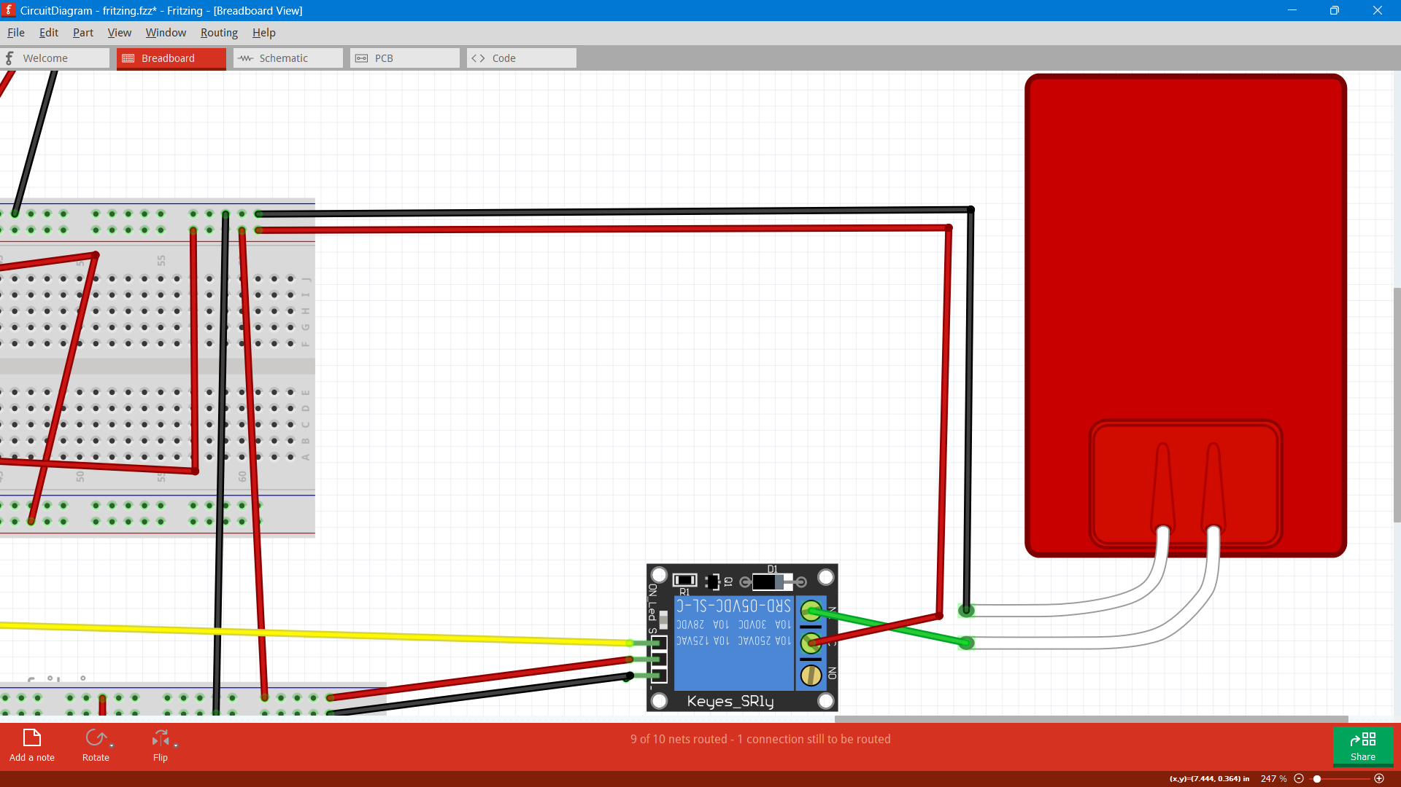

Figure 4.9: Relay to heater connection diagram

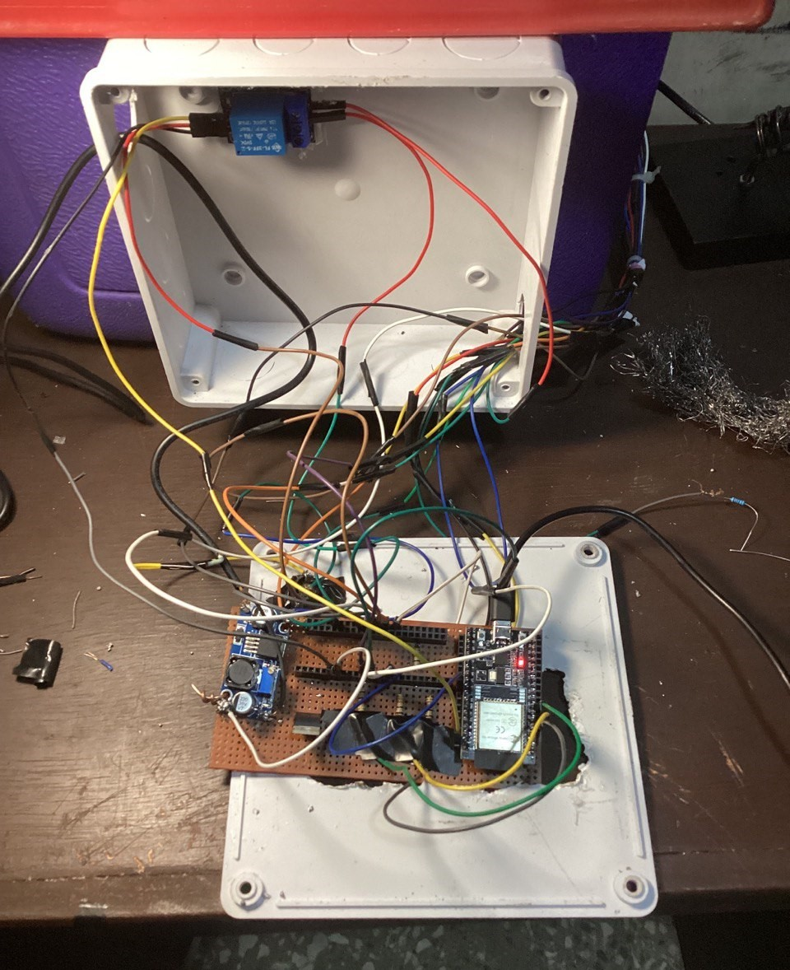

Figure 4.10: Image showing final soldering and wiring

### 4.3 LDR calibration and testing

The Light Dependent Resistor (LDR) plays a vital role in the project as it provides resistance values that are essential for drawing final conclusions and inferring the presence of coliform contamination in the tested water sample.

To obtain resistance readings from the LDR, a voltage divider circuit is employed by connecting a known resistor in series with the LDR. This circuit setup allows for the division of voltage across the resistors, enabling the measurement of the LDR's resistance based on the resulting voltage values. By analyzing the resistance readings obtained from the LDR, conclusions can be drawn regarding the potential contamination of the water sample with coliform.

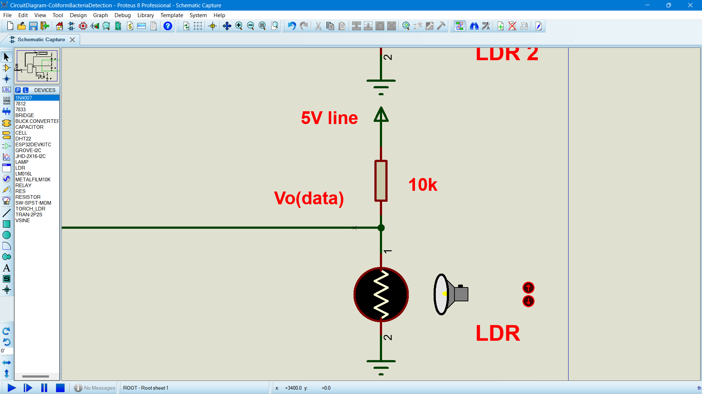

Figure 4.11: Voltage divider circuit for LDR

The voltage across the Light Dependent Resistor (LDR) and the known resistor undergoes changes as the resistance of the LDR varies in response to alterations in light intensity. In the voltage divider circuit, the junction of the LDR and the known resistor is connected to an analog input pin on the ESP board. This analog input pin detects the voltage at the junction and converts it into a digital value that can be read and processed by the ESP.

By reading the voltage at the LDR and known resistor junction through the analog input pin, it is possible to determine the state of the LDR's resistance. When the LDR resistance is high (under low lighting conditions), the voltage across the LDR will be higher compared to the known resistor. Conversely, in bright light conditions where the LDR resistance is low, the voltage across the LDR will be lower relative to the known resistor.

To convert the measured voltage into a digital value, an Analog-to-Digital Converter (ADC) is utilized. Typically, the ESP board incorporates a built-in ADC that can effectively convert the analog voltage into a digital value within a specific range.

#### 4.3.1 Calibration and Mapping of LDRs

To capture the characteristics of each LDR, resistance readings were recorded in two scenarios: with the LED turned on and with the LED turned off. The purpose of obtaining the resistance reading with the LED off is to establish the maximum resistance value for each LDR. When the LED is illuminated, all LDRs exhibit a resistance reading of approximately 0 ohms. This process is crucial in determining an appropriate range for the subsequent LDR readings.

Here are the approximate resistance readings obtained from the serial monitor:

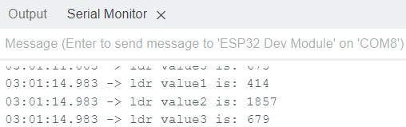

Figure 4.12: Serial monitor readings of LDR resistance readings while LED off

These values are mapped on a scale of 0-100 so we can visualize the values in real time using the blynk platform.

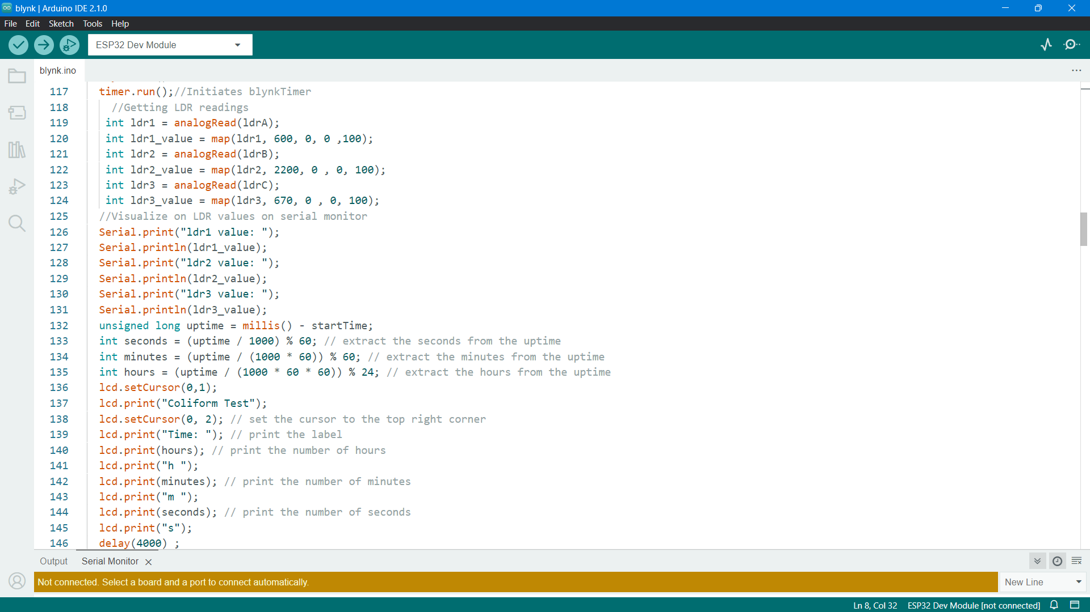

Figure 4.13: Code showing mapped LDR resistance values

To conduct our testing, we begin by adding 100ml of water to the pre-weighted bottles containing the powder samples. These bottles are specifically prepared for our testing purposes. The resulting mixture is then placed in the incubator and incubated for a duration of 16 hours.

To validate the accuracy of our testing method and calibrate our system, we introduce samples of coliform bacteria obtained from a microbiology laboratory into the water samples. This ensures that our water samples are deliberately contaminated with coliform bacteria. The presence of coliform bacteria in the water samples is indicated by a noticeable color change, which serves as an important indicator of the bacterial contamination we are targeting in our testing process.

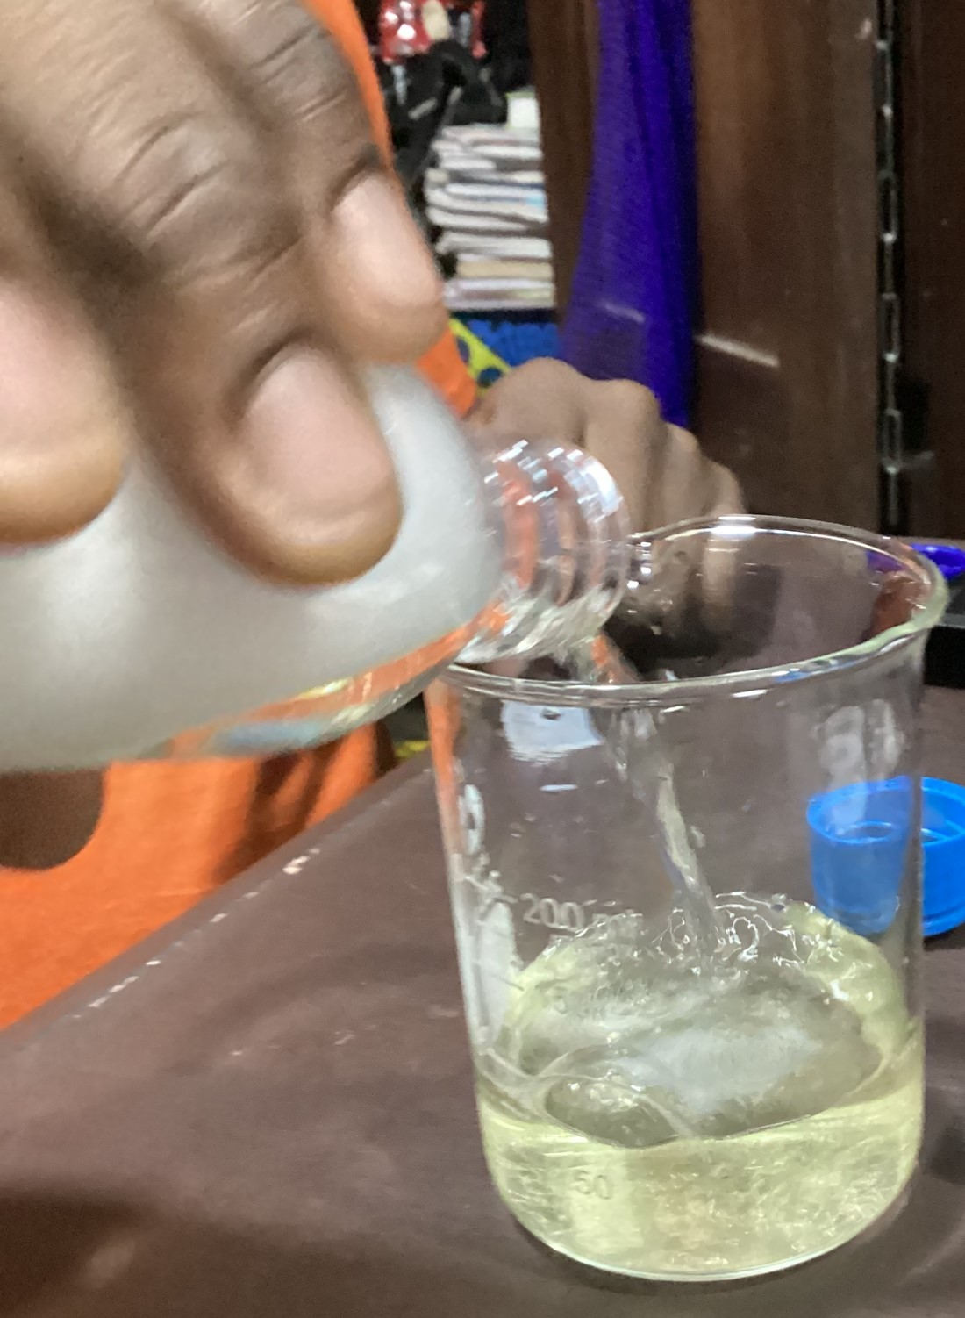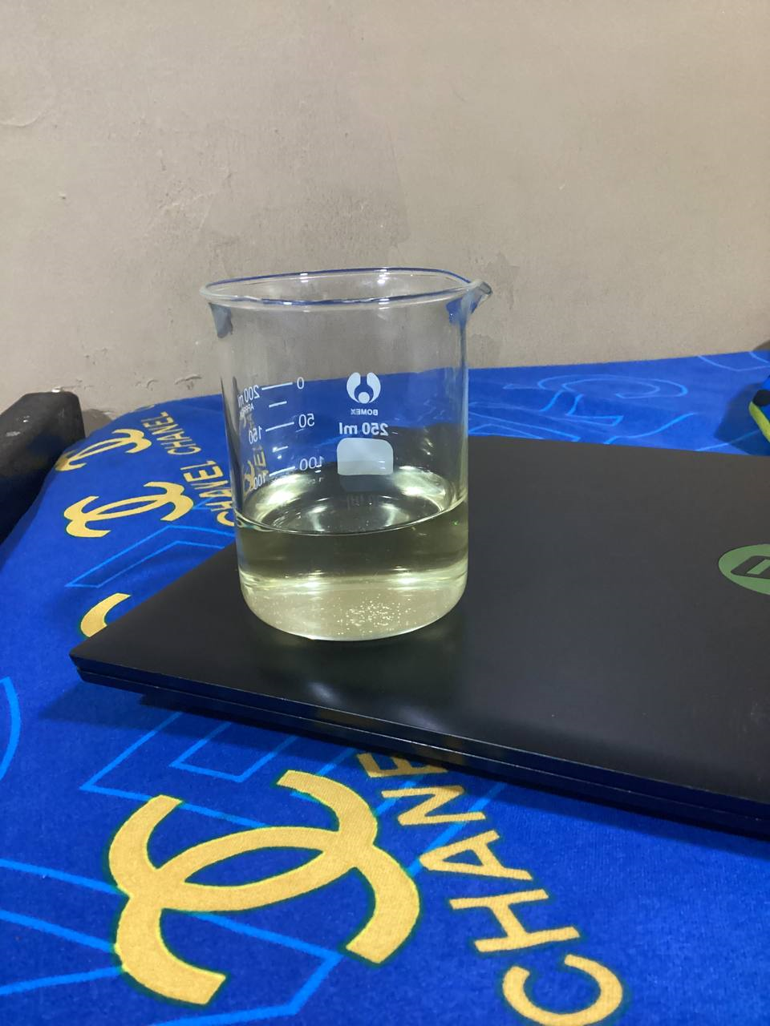

Figure 4.14: Water sample containing coliform bacteria mixed with water detect coliform powder

After the incubation period of 16 hours, an observable transformation takes place in the water sample that has been infected with coliform bacteria. Initially, the color of the infected sample is a golden hue. However, as a result of the presence of coliform bacteria, the color of the water changes to a dark greenish shade accompanied by significant cloudiness. On the other hand, an uninfected water sample retains its original golden color and remains clear after the same incubation duration.

The color change in the infected sample is attributed to the enzymatic activity of coliform bacteria, specifically an enzyme called β-galactosidase. Under the optimum temperature range of 35 to 37 degrees Celsius (°C) required for their growth, coliform bacteria generate acids and gases through the action of this enzyme. In the presence of a chromogenic substrate known as indoxyl-b-D-glucuronide (IBDG), the breakdown of this substrate by β-galactosidase leads to the production of a fluorescent compound. In the specific case described, this fluorescence manifests as a green coloration, thus indicating the presence of coliform bacteria in the infected water sample.

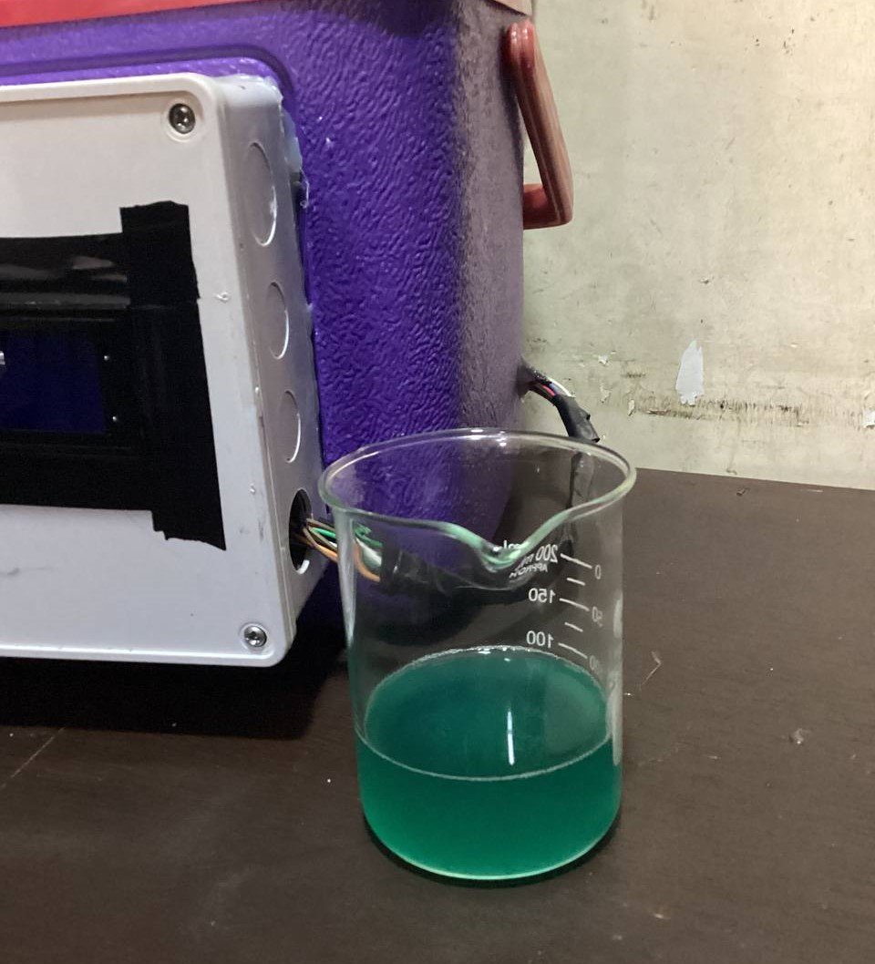

Figure 4.15 : Water sample after 16 hours of incubation

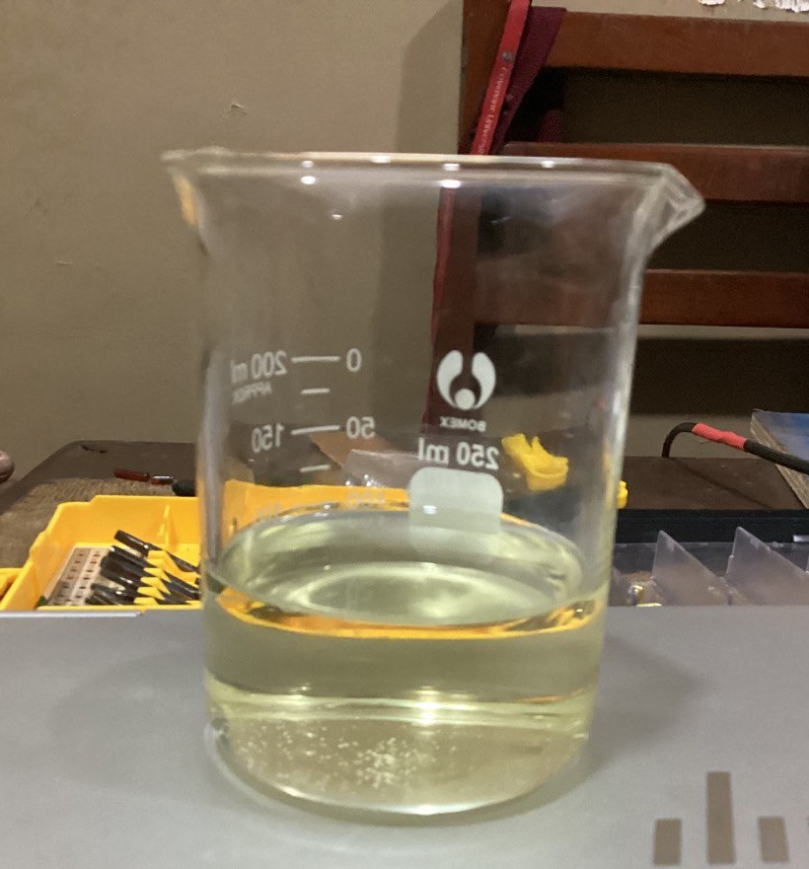

Figure 4.16: Color of water sample uninfected with coliform bacteria after 16 hours of incubation

The beaker holding a green, turbid water sample contaminated with coliform bacteria was employed to establish a standard resistance range for our Light Dependent Resistors (LDRs) when encountering coliform-contaminated water. This calibration process took into account the sensitivity of our LDRs. Subsequently, the beaker was successively placed on LDR 1, LDR 2, and LDR 3. The resulting resistances are presented below.

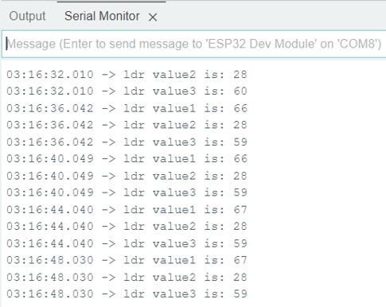

Figure 4.17: LDR readings when beaker with contaminated water was placed on each LDR

#### 4.3.2 Final results

By utilizing the calibration of our LDR (Light Dependent Resistors), we can determine the presence or absence of coliform bacteria in water. The LDR readings obtained during the calibration process enable users to assess whether a specific water sample under testing is contaminated with coliform bacteria or not. This information provides valuable insights regarding the bacterial contamination status of the water sample.

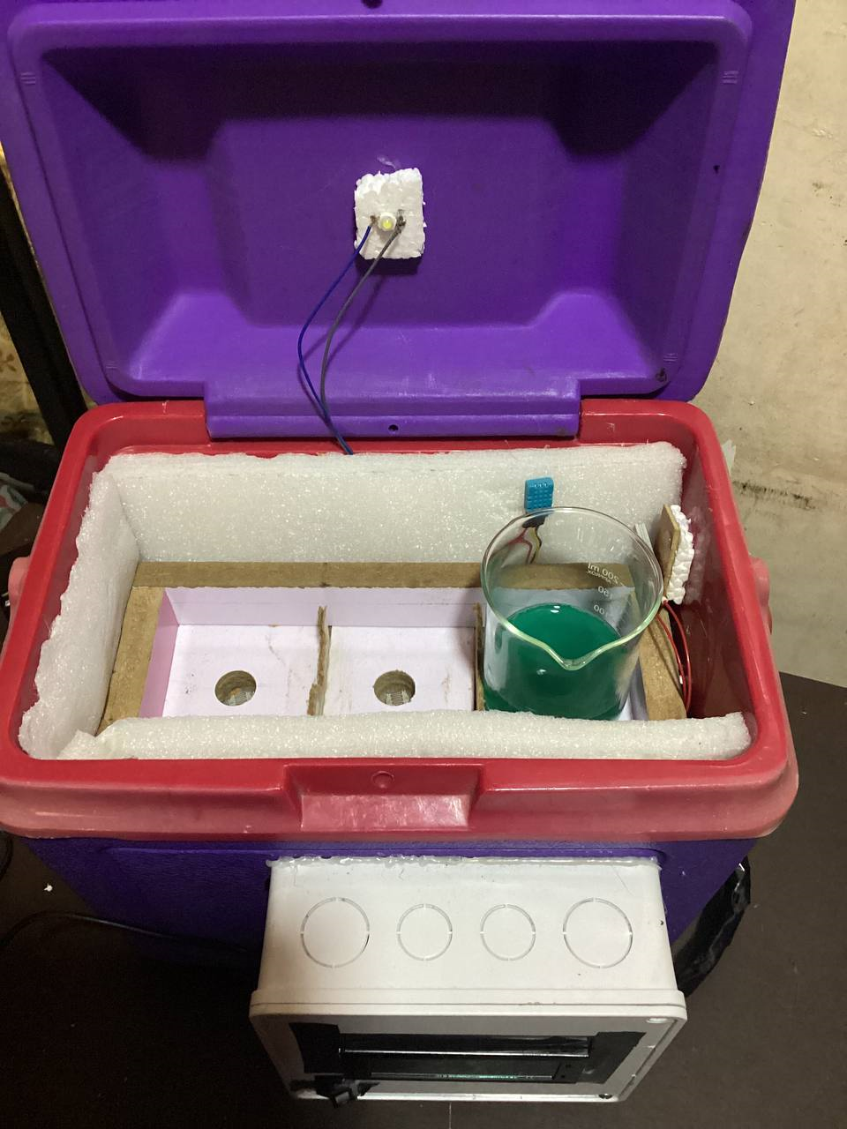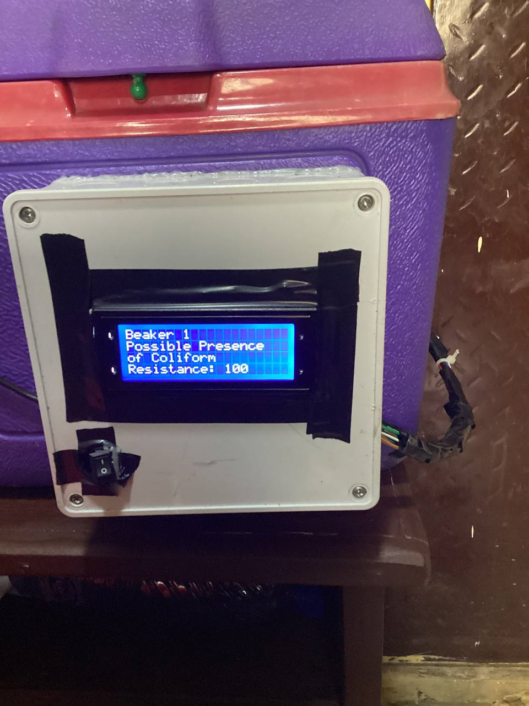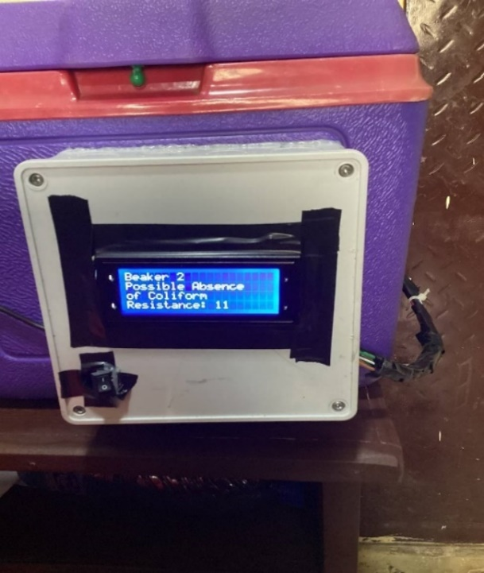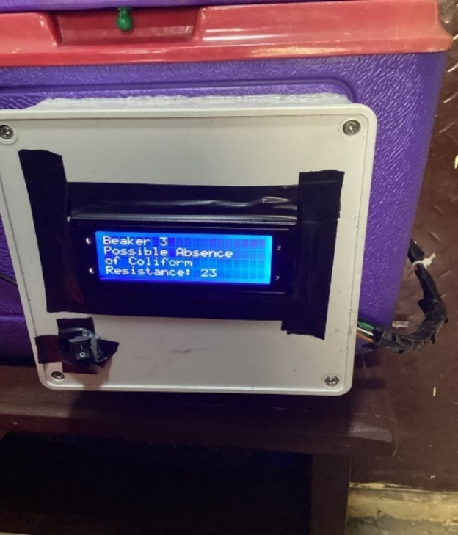

Figure 4.18: Showing results when sample beaker is on LDR 1

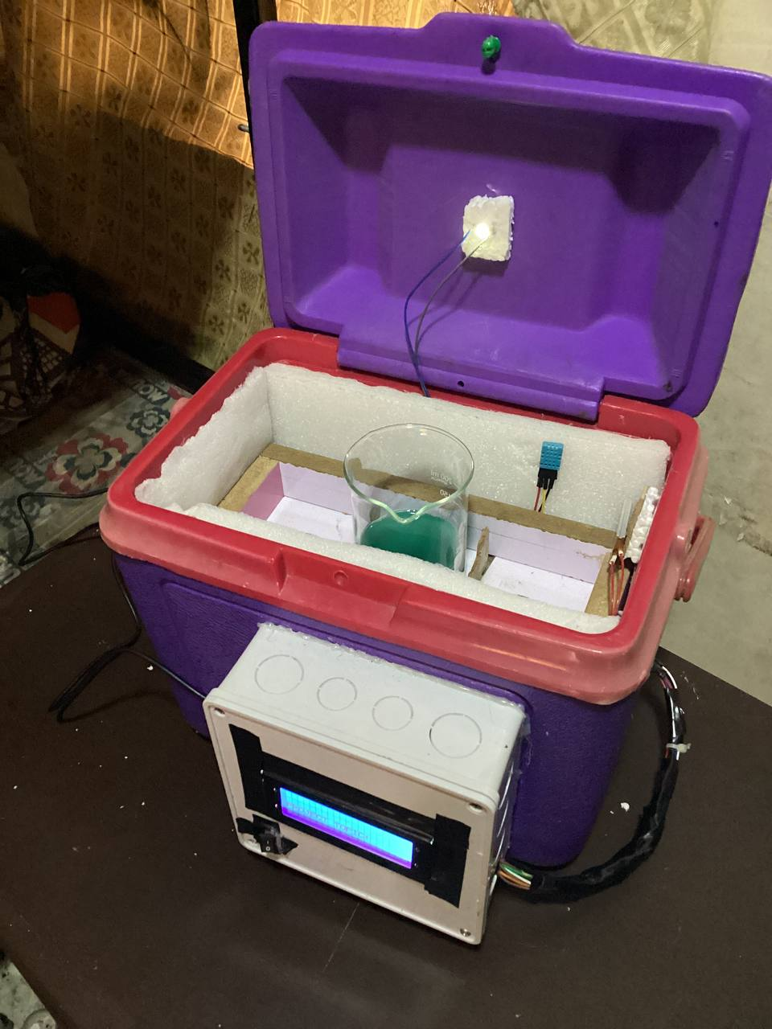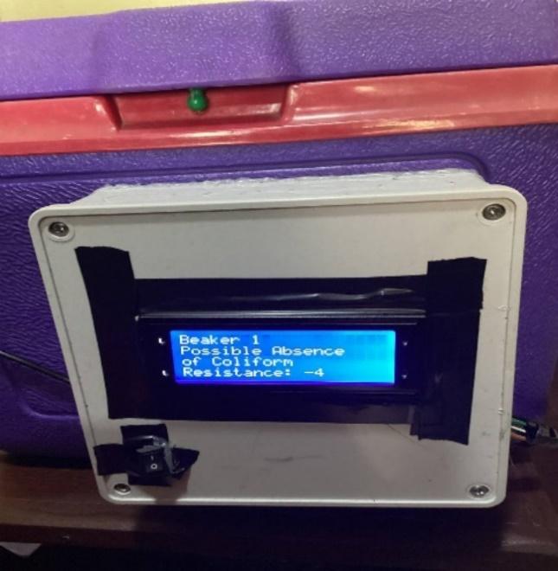

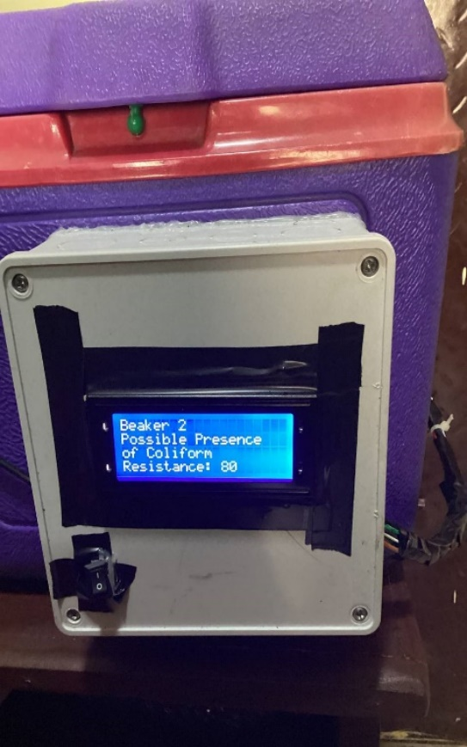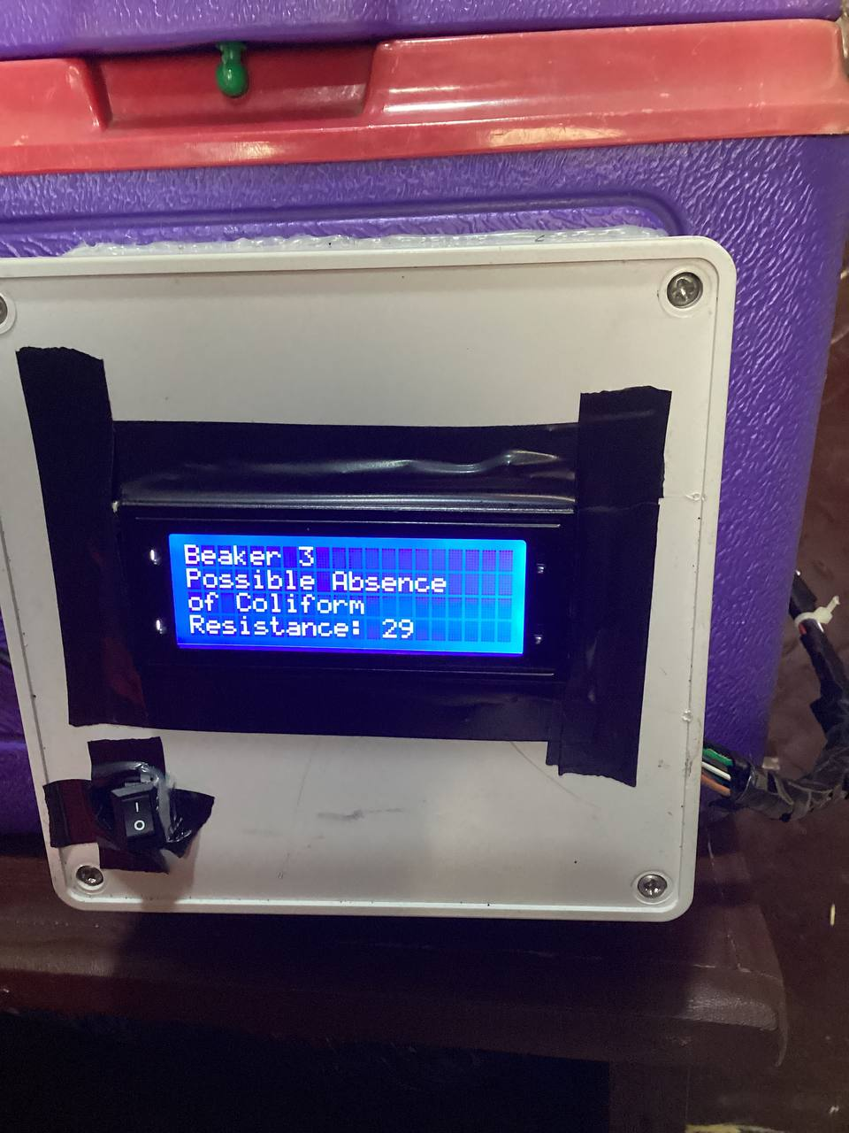

Figure 4.19: Showing results when sample beaker is on LDR 2

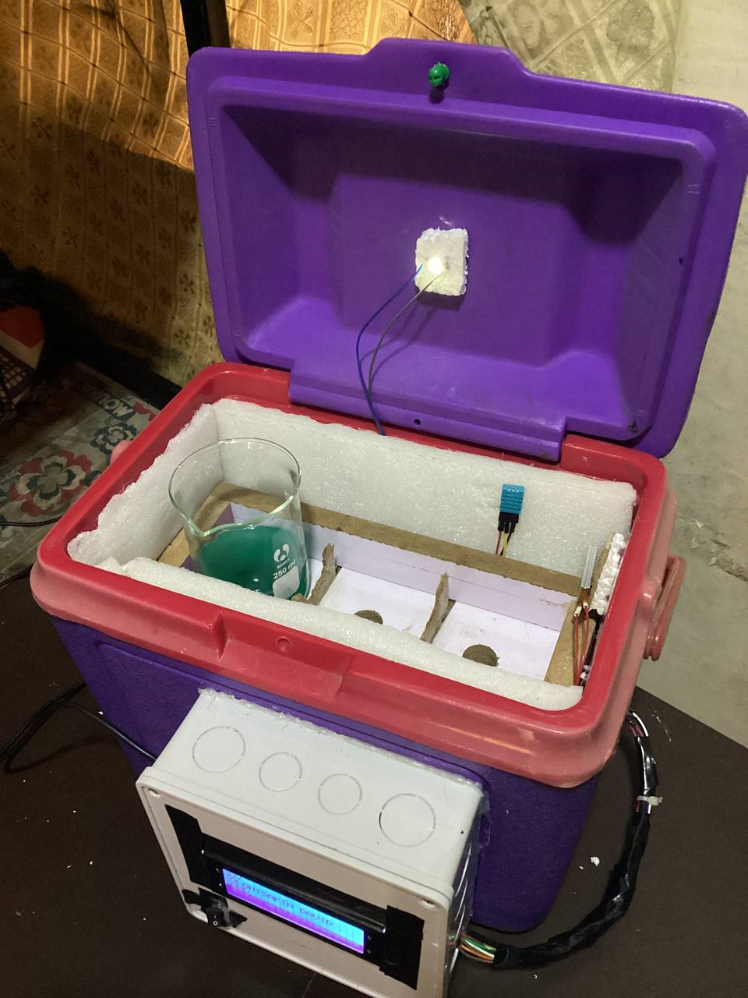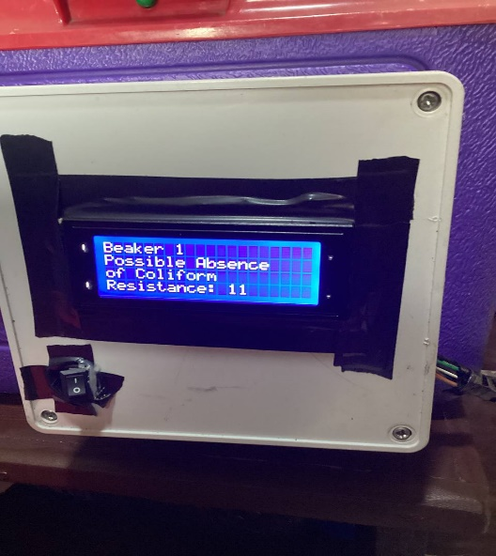

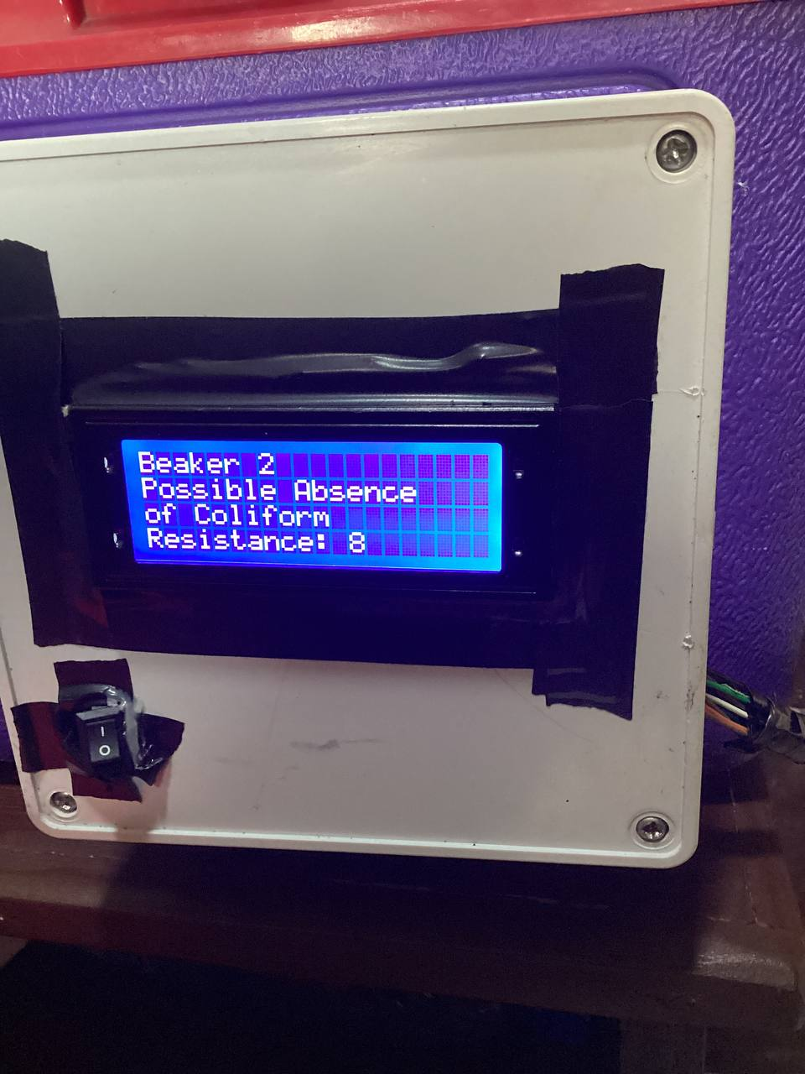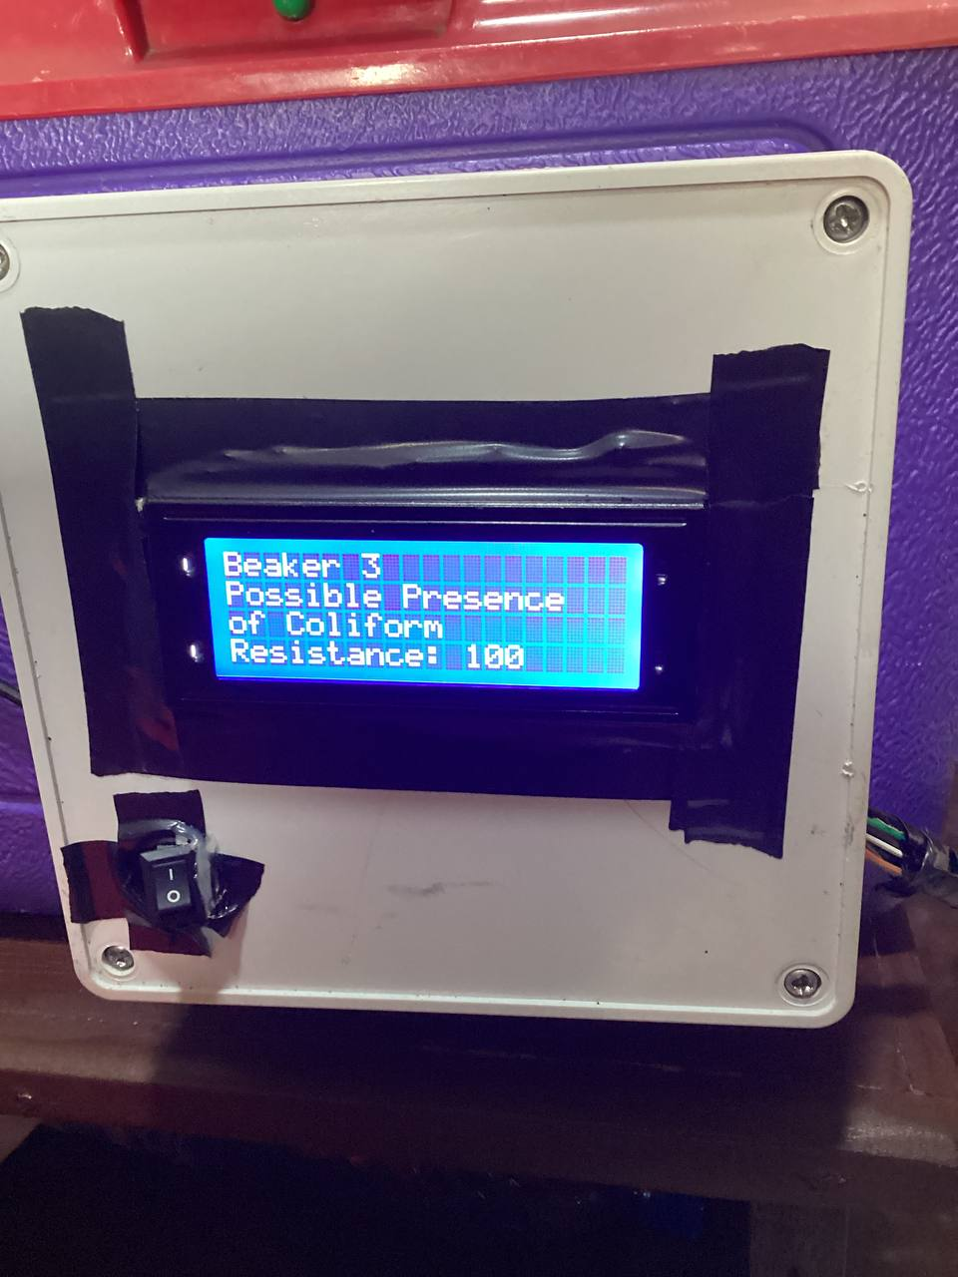

Figure 4.20: Showing results when sample beaker is on LDR 3

### 4.4 Bill Of Engineering Material and Evaluation (B.E.M.E)

Table 4.1: Bill Of Engineering Material and Evaluation (B.E.M.E)

|  |  |  |  |  |
| --- | --- | --- | --- | --- |
| S/N | COMPONENTS | QUUANTITY | UNIT PRICE (₦) | TOTAL COST (₦) |
| 1 | Water detect coliform powder | 1 | 37,000.00 | 37,000.00 |
| 2 | AC/DC power adapter | 1 | 3,500 | 3,500.00 |
| 3 | Buck converter | 1 | 1,700 | 1,700.00 |
| 4 | ESP32 | 1 | 8,000.00 | 8,000.00 |
| 5 | LDR | 3 | 300.00 | 900.00 |
| 6 | 3.3v voltage regulator | 1 | 120.00 | 120.00 |
| 7 | Liquid Crystal Display | 1 | 4,850.00 | 4,850.00 |
| 8 | I2C module | 1 | 1,400.00 | 1,400.00 |
| 9 | 10K resistor | 4 | 10.00 | 40.00 |
| 10 | Hot glue gun | 1 | 3,240.00 | 3,240.00 |
| 11 | Cooler | 1 | 20,000 | 20,000.00 |
| 12 | DHT11 | 1 | 1,440.00 | 1,440.00 |
| 13 | PTC heating element | 1 | 3,500.00 | 3,500.00 |
| 14 | Single channel relay | 1 | 800.00 | 800.00 |
| 15 | Pattress box | 1 | 1,500 | 1,500 |
|  |  |  | **TOTAL** | 87,990 |

### 4.5 Summary

The project's findings are presented in this chapter. The project was assessed in conjunction with the goals listed in Chapter One, and the operation and functionality of the system were examined to make sure they adhered to the design standards. Additionally, it displays a variety of images from both the testing process and the end outcomes. There is also a Bill of Engineering Measurement and Evaluation available.

# CHAPTER FIVE

## CONCLUSIONS AND RECOMMENDATIONS

### 5.1 Conclusion

In this chapter, the conclusions of the project "Development of a Portable Incubator for the Detection of Coliform in Water Using IoT" are presented. The project aimed to achieve several objectives, including designing and constructing a portable incubator capable of maintaining temperatures between 35 and 37 °C, integrating an LDR sensor and light source for coliform detection, and creating a Blynk app for real-time monitoring and data presentation. The following conclusions have been derived from the project:

1. The successful design and construction of the portable incubator have provided a controlled environment for the growth and detection of coliform bacteria in water samples. The combination of the relay and heating source has enabled precise temperature control within the required range.

2. The LDR sensor has demonstrated its ability to detect changes in resistance, allowing for the monitoring of coliform bacteria presence and growth. By calibrating the LDR readings and correlating them with coliform levels, real-time monitoring and data visualization have been made possible through the Blynk app.

3. The Blynk app has proven to be a valuable tool for data analysis and remote monitoring. Its user-friendly interface facilitates the visualization of coliform levels, enabling prompt decision-making based on the gathered information.

### 5.2 Achievements

The project effectively fulfilled the stated objectives:

1. Designing and constructing a portable incubator capable of maintaining a temperature range of 35-37°C using a relay for heating control.

2. Utilizing an LDR sensor and light bulb to monitor changes in resistance and identify the growth of coliform bacteria.

3. Creating a Blynk app for real-time tracking of coliform levels and displaying statistical data.

### 5.3 Challenges encountered

Throughout the project, we encountered various obstacles, including:

1. Calibration of the LDR sensor: Achieving accurate and consistent readings from the LDR sensor for reliable coliform bacteria detection posed a challenge. It necessitated meticulous calibration and adjustments.
2. Acquiring water samples contaminated with coliform bacteria: Ensuring the availability of coliform-contaminated water samples for testing purposes was difficult due to safety and regulatory considerations. It required taking necessary steps to guarantee the integrity of the collected samples.
3. Ensuring uniform heating within the incubator: Maintaining consistent heat distribution inside the incubator proved to be a challenge. Even slight temperature variations could interfere with the growth and detection of coliform bacteria. To address this issue, we focused on optimizing the heating system and insulating materials.
4. Soldering components: The soldering process required precision and composure to connect numerous components effectively. Inadequate soldering could lead to faulty connections and system failure. We exercised great care and consideration to ensure proper soldering procedures and prevent any potential damage to the components.

### 5.4 Recommendations

Based on the project's experience, the following recommendations are provided for future development and work:

1. Enhance LDR calibration: Further calibration and refinement of the LDR sensor can enhance the accuracy and sensitivity of coliform detection. Exploring advanced calibration procedures and utilizing data processing algorithms may yield more precise readings.

2. Expand testing with diverse water samples: Testing a wider range of water samples, encompassing different sources and contamination levels, would enhance the robustness and reliability of the detection system.

3. Optimize heating system and insulation: Continuous improvements to the heating system and insulation materials should be pursued to ensure temperature uniformity within the incubator. This will contribute to accurate and consistent results when detecting coliform bacteria.

4. Integration with additional sensors: Integrating additional sensors such as pH sensors or turbidity sensors can enable the creation of a comprehensive water quality monitoring system. This expansion would allow for the detection of different contaminants and provide a more comprehensive evaluation of water safety.

5. Alternative methods for color change detection: While the LDR sensor effectively detected color changes indicative of coliform growth, exploring alternative techniques such as cameras and computer vision could offer more detailed information. These methods have the potential to increase accuracy and efficiency by automatically analyzing visual changes. However, it should be noted that these approaches may involve higher costs and technical challenges.

6. Collaboration with regulatory bodies and water authorities: Collaborating with relevant regulatory organizations and water management entities is essential to ensure widespread adoption and impact of the portable incubator. Engaging in partnerships and discussions with these entities can help validate data, gain insightful information, and advance the establishment of standardized guidelines for water quality monitoring.

## REFERENCES

[1] A. Sarker, S. Dash, M. M. Hoque, S. Ahmed, and M. R. Shaheb, “Assessment of microbial quality of water in popular restaurants in Sylhet city of Bangladesh,” *Bangladesh Journal of Agricultural Research*, vol. 41, no. 1, pp. 115–125, 2016, doi: 10.3329/bjar.v41i1.27677.

[2] A. Schertenleib, J. Sigrist, M. N. D. Friedrich, C. Ebi, F. Hammes, and S. J. Marks, “Construction of a low-cost mobile incubator for field and laboratory use,” *JoVE (Journal of Visualized Experiments)*, no. 145, p. e58443, 2019.

[3] “Coliform Bacteria and Drinking Water,” no. April, 2011.

[4] P. Pal, “Detection of Coliforms in Drinking Water and its Effect on Human Health - A Review,” *International Letters of Natural Sciences*, vol. 17, pp. 122–131, 2014, doi: 10.18052/www.scipress.com/ilns.17.122.

[5] L. K. Bhardwaj and T. Jindal, “Evaluation of Coliform and Faecal Coliform Bacteria in the Lakes of Broknes and Grovnes Peninsula, East Antarctica,” *Nature Environment and Pollution Technology*, vol. 21, no. 5, pp. 2025–2034, 2022, doi: 10.46488/NEPT.2022.v21i05.002.

[6] P. Taylor, M. V Yates, S. R. Yates, and C. P. Gerba, “Critical Reviews in Environmental Control Modeling microbial fate in the subsurface environment,” no. March 2015, pp. 37–41, doi: 10.1080/10643388809388339.

[7] L. Niyoyitungiye, A. Giri, and M. Ndayisenga, “Assessment of Coliforms Bacteria Contamination in Lake Tanganyika as Bioindicators of Recreational and Drinking Water Quality,” *South Asian Journal of Research in Microbiology*, no. June, pp. 9–16, 2020, doi: 10.9734/sajrm/2020/v6i330150.

[8] F. M. Khan and R. Gupta, “Escherichia coli (e. coli) as an indicator of fecal contamination in groundwater: A review,” *Environmental Science and Engineering*, no. October, pp. 225–235, 2020, doi: 10.1007/978-3-030-45263-6_21.

[9] M. V. Yates and S. R. Yates, “Modeling microbial fate in the subsurface environment,” *Critical Reviews in Environmental Control*, vol. 17, no. 4, pp. 307–344, 1988, doi: 10.1080/10643388809388339.

[10] “EFFECT OF SEPTIC TANKS CONTAMINATION ON GROUNDWATER QUALITY AROUND ELEMENTARY SCHOOL IN IBADAN , OYO STATE NIGERIA,” no. March, 2023.

[11] S. Rafael, G. Lenn, and F. Yekeh, “Impact Of Constructing Septic Tanks in Close Proximity to Boreholes ( Ground Water ): The Case Of Kesselly Boulevard Community in Montserrado County , Original Research Paper Health Science IMPACT OF CONSTRUCTING SEPTIC TANKS IN CLOSE PROXIMITY TO,” no. June, 2021.

[12] V. O. Adetunji and I. A. Odetokun, “Groundwater contamination in Agbowo community , Ibadan Nigeria : Impact of septic tanks distances to wells,” vol. 7, no. 3, pp. 159–166, 2011.

[13] C. Y. Lin, M. H. Abdullah, B. Musta, A. Z. Aris, and S. M. Praveena, “Assessment of selected chemical and microbial parameters in groundwater of Pulau Tiga, Sabah, Malaysia,” *Sains Malays*, vol. 39, no. 3, pp. 337–345, 2010.

[14] “Guidelines for Canadian Drinking Water Quality: Guideline Technical Document – Enteric Viruses - Canada.ca.” https://www.canada.ca/en/health-canada/services/publications/healthy-living/guidelines-canadian-drinking-water-quality-guideline-technical-document-enteric-viruses.html (accessed Mar. 30, 2023).

[15] E. O. Longe and M. R. Balogun, “Groundwater quality assessment near a municipal landfill, Lagos, Nigeria,” *Research Journal of Applied Sciences, Engineering and Technology*, vol. 2, no. 1, pp. 39–44, 2010.

[16] K. Yusuf, “Groung Water in Lagos.Pdf.” [Online]. Available: http://www.docsdrive.com/pdfs/ansinet/jas/2007/1780-1784.pdf

[17] E. O. Orebiyi, J. A. Awomeso, O. A. Idowu, O. Martins, O. Oguntoke, and A. M. Taiwo, “Assessment of pollution hazards of shallow well water in Abeokuta and environs, southwest, Nigeria,” *Am J Environ Sci*, vol. 6, no. 1, pp. 50–56, 2010, doi: 10.3844/ajessp.2010.50.56.

[18] U. A. P. & Dr. O. a A. A, “Exploratory Survey of Geochemical Aspects of Underground Water in Ehime Mbano Area Se Nigeria,” *Global Journals of Research in Engineering, 11(4)*, vol. 11, no. 4, pp. 15–22, 2011.

[19] H. M. Solo-gabriele, M. A. Wolfert, T. R. Desmarais, and C. J. Palmer, “Sources of Escherichia coli in a Coastal Subtropical Environment,” vol. 66, no. 1, pp. 230–237, 2000.

[20] P. Harcourt, “The Effect of Septic Tank Locations on Borehole Water Quality in,” vol. 4, no. 5, 2014.

[21] “Management Plan to Reduce the Adverse Effects of Proximity of Dug Wells and Septic Tanks in Urban Area to Diminish Coliform Contamination,” vol. 7, no. 3, 2016.

[22] R. J. Perkins, “Septic tanks, lot size and pollution of water table aquifers,” *J Environ Health*, vol. 46, no. 6, pp. 298–304, 1984.

[23] M. V. Yates and S. R. Yates, “Septic Tank Setback Distances: A Way to Minimize Virus Contamination of Drinking Water,” *Groundwater*, vol. 27, no. 2. pp. 202–208, 1989. doi: 10.1111/j.1745-6584.1989.tb00441.x.

[24] “Environmental Impacts of Agricultural Modifications.” https://education.nationalgeographic.org/resource/environmental-impacts-agricultural-modifications/ (accessed Mar. 30, 2023).

[25] J. A. Entry and N. Farmer, “Movement of Coliform Bacteria and Nutrients in Ground Water Flowing through Basalt and Sand Aquifers,” *J Environ Qual*, vol. 30, no. 5, pp. 1533–1539, 2001, doi: 10.2134/jeq2001.3051533x.

[26] N. Sasakova *et al.*, “Pollution of Surface and Ground Water by Sources Related to Agricultural Activities,” vol. 2, no. July, 2018, doi: 10.3389/fsufs.2018.00042.

[27] “Agricultural Contaminants | U.S. Geological Survey.” https://www.usgs.gov/mission-areas/water-resources/science/agricultural-contaminants (accessed Mar. 30, 2023).

[28] “Poor Farming Practices & How They Affect Your Food – Thriving Yard.” https://thrivingyard.com/poor-farming-practices-how-they-affect-your-food/ (accessed Mar. 30, 2023).

[29] P. K. Weiskel, B. L. Howes, and G. R. Heufelder, “Coliform Contamination of a Coastal Embayment:  Sources and Transport Pathways,” *Environ Sci Technol*, vol. 30, no. 6, pp. 1872–1881, 1996, doi: 10.1021/ES950466V.

[30] A. O. Sojobi, “Evaluation of groundwater quality in a rural community in North Central of Nigeria,” *Environ Monit Assess*, vol. 188, no. 3, pp. 1–17, Mar. 2016, doi: 10.1007/S10661-016-5149-Y.

[31] P. Rajapaksha, A. Elbourne, S. Gangadoo, R. Brown, D. Cozzolino, and J. Chapman, “A review of methods for the detection of pathogenic microorganisms,” *Analyst*, vol. 144, no. 2, pp. 396–411, Jan. 2019, doi: 10.1039/C8AN01488D.

[32] S. N. Zulkifli, H. A. Rahim, and W.-J. Lau, “Detection of contaminants in water supply: A review on state-of-the-art monitoring technologies and their applications,” *Sens Actuators B Chem*, vol. 255, pp. 2657–2689, 2018.

[33] A. Verma, “Environmental Ethics : Need to Rethink Environmental Ethics : Need to Rethink,” no. July, pp. 1–4, 2020.

[34] M. Pal, Y. Ayele, A. Hadush, S. Panigrahi, and V. J. Jadhav, “Air & Water Borne Diseases Public Health Hazards Due to Unsafe Drinking Water,” vol. 7, no. 1, pp. 1–6, 2018, doi: 10.4172/2167-7719.1000138.

[35] P. Martins, N. O. Forstinus, and N. E. Ikechukwu, “Water and Waterborne Diseases : A Review Water and Waterborne Diseases : A Review,” no. January, 2016, doi: 10.9734/IJTDH/2016/21895.

[36] M. N. Iqbal and A. Ashraf, “Water Quality a Priority for Profitable Fish Farming,” *PSM Biological Research*, vol. 5, no. 2, pp. 92–94, 2020.

[37] A. S. Yusuff, W. John, and A. C. Oloruntoba, “Review on prevalence of waterborne diseases in Nigeria,” *J Adv Med Life Sci*, vol. 1, no. 2, pp. 1–3, 2014.

[38] “Drinking-water.” https://www.who.int/en/news-room/fact-sheets/detail/drinking-water (accessed Mar. 31, 2023).

[39] A. D. Lopez and C. D. Mathers, “Measuring the global burden of disease and epidemiological transitions: 2002–2030,” *Ann Trop Med Parasitol*, vol. 100, no. 5–6, pp. 481–499, 2006.

[40] W. J. W. Supply and S. M. Programme, *Progress on drinking water and sanitation: 2014 update*. World Health Organization, 2014.

[41] K. Khan *et al.*, “Prevalent fecal contamination in drinking water resources and potential health risks in Swat, Pakistan,” *Journal of Environmental Sciences*, pp. 1–12, 2017, doi: 10.1016/j.jes.2017.12.008.

[42] M. J. Allen, S. C. Edberg, J. L. Clancy, and S. E. Hrudey, “Drinking water microbial myths,” *Crit Rev Microbiol*, vol. 41, no. 3, pp. 366–373, 2015.

[43] R. Bain, R. Johnston, and T. Slaymaker, “Drinking water quality and the SDGs,” *NPJ Clean Water*, vol. 3, no. 1, pp. 7–9, 2020, doi: 10.1038/s41545-020-00085-z.

[44] P. Servais, J. Baudart, and A. Rompre, “Detection and enumeration of coliforms in drinking water : current methods and emerging approaches,” vol. 49, pp. 31–54, 2002.

[45] K. Gilbride, *Molecular Methods for the Detection of Waterborne Pathogens*. Elsevier, 2013. doi: 10.1016/B978-0-444-59543-0.00008-6.

[46] “Polymerase chain reaction - Wikipedia.” https://en.wikipedia.org/wiki/Polymerase_chain_reaction (accessed Mar. 31, 2023).

[47] “Detection of coliform bacteria in water by polymerase chain reaction and gene probes | Applied and Environmental Microbiology.” https://journals.asm.org/doi/full/10.1128/aem.56.2.307-314.1990 (accessed Mar. 31, 2023).

[48] S. F. Hussin and Z. Saari, “The Portable Incubator For E. coli and Coliform Bacterial Growth Using IoT,” *Advances in Computing and Intelligent System*, vol. 2, no. 1, 2020.

[49] M. Principle, T. Procedure, I. Results, and S. Life, “Water Detect Coliforms,” pp. 2–4, 2016.

[50] “Coliform bacteria - Wikipedia.” https://en.wikipedia.org/wiki/Coliform_bacteria (accessed Mar. 31, 2023).

[51] “The Internet of Things (IoT): An Overview - Internet Society.” https://www.internetsociety.org/resources/doc/2015/iot-overview/ (accessed Mar. 30, 2023).

[52] P. M. Pujar, H. H. Kenchannavar, R. M. Kulkarni, and U. P. Kulkarni, “Real ‑ time water quality monitoring through Internet of Things and ANOVA ‑ based analysis : a case study on river Krishna,” *Appl Water Sci*, 2020, doi: 10.1007/s13201-019-1111-9.

[53] “What is IoT (Internet of Things)? | Microsoft Azure.” https://azure.microsoft.com/en-us/resources/cloud-computing-dictionary/what-is-iot/ (accessed Mar. 30, 2023).

[54] M. J. Mudumbe and A. M. Abu-Mahfouz, “Smart water meter system for user-centric consumption measurement,” in *2015 IEEE 13th international conference on industrial informatics (INDIN)*, IEEE, 2015, pp. 993–998.

[55] K. Upadhyay, A. K. Yadav, and P. Gandhi, “A review of internet of things from Indian perspective,” *Engineering Vibration, Communication and Information Processing: ICoEVCI 2018, India*, pp. 621–632, 2019.

[56] R. Krishnamurthi, A. Kumar, D. Gopinathan, A. Nayyar, and B. Qureshi, “An overview of IoT sensor data processing, fusion, and analysis techniques,” *Sensors*, vol. 20, no. 21, p. 6076, 2020.

[57] S. Sanyal and P. Zhang, “Improving quality of data: IoT data aggregation using device to device communications,” *IEEE Access*, vol. 6, pp. 67830–67840, 2018.

[58] S. A. H. Almetwally, M. K. Hassan, and M. H. Mourad, “Real Time Internet of Things (IoT) Based Water Quality Management System,” *Procedia CIRP*, vol. 91, pp. 478–485, 2020, doi: 10.1016/j.procir.2020.03.107.

[59] M. Singh and S. Ahmed, “IoT based smart water management systems: A systematic review,” *Mater Today Proc*, vol. 46, pp. 5211–5218, 2021.

[60] “Data Analysis and Visualization in an IOT Dashboard.” https://psiborg.in/data-analysis-and-visualization-in-an-iot-dashboard/ (accessed Mar. 31, 2023).

[61] H. Khurshid *et al.*, “Bacterial prediction using internet of things (IoT) and machine learning,” *Environ Monit Assess*, vol. 194, no. 2, p. 133, 2022.

[62] U. Ahmed, R. Mumtaz, H. Anwar, S. Mumtaz, and A. M. Qamar, “Water quality monitoring: from conventional to emerging technologies,” *Water Supply*, vol. 20, no. 1, pp. 28–45, 2020.

[63] F. Jan, N. Min-Allah, and D. Düştegör, “Iot based smart water quality monitoring: Recent techniques, trends and challenges for domestic applications,” *Water (Basel)*, vol. 13, no. 13, p. 1729, 2021.

[64] N. S. Kamaruidzaman and S. N. Rahmat, “Water monitoring system embedded with internet of things (IoT) device: a review,” in *IOP conference series: Earth and environmental science*, IoP Publishing, 2020, p. 12068.

[65] B. T. Heligman *et al.*, “The design and usage of a portable incubator for inexpensive in-field water analysis,” *Journal of Humanitarian Engineering*, vol. 6, no. 2, 2018.

[66] A. Schertenleib, J. Sigrist, M. N. D. Friedrich, C. Ebi, F. Hammes, and S. J. Marks, “Construction of a Low-cost Mobile Incubator for Field and Laboratory Use Construction of a Low-cost Mobile Incubator for Field and Laboratory Use,” no. March, 2019, doi: 10.3791/58443.

[67] S. N. Ibrahim, A. L. Asnawi, N. Abdul Malik, N. F. Mohd Azmin, A. Z. Jusoh, and F. N. Mohd Isa, “Web based Water Turbidity Monitoring and Automated Filtration System: IoT Application in Water Management.,” *International Journal of Electrical & Computer Engineering (2088-8708)*, vol. 8, no. 4, 2018.

[68] S. Manoharan, G. Sathiyaraj, K. Thiruvenkadakrishnan, G. V Vetriselvan, and P. Kishor, “Water quality analyzer using IoT,” *Int. J. Innov. Technol. Explor. Eng*, vol. 8, pp. 34–37, 2019.